Complete list of A1 grammar contents
This is a list of all the grammar topics covered in level A1. But if you want to learn A1 grammar, we recommend studying the topics in the order that they appear in: Grammar points » A1 Grammar lessons and exercises.

Present tenses
A1 Present simple forms of ‘to be’: am/is/are
A1 Present simple: I do, I don’t, Do I?
A1 Present continuous: I’m doing, I’m not doing, Are you doing?
A1 Present simple or present continuous?
A1 Have got

Past tenses
A1 Was/were: Past simple of ‘be’
A1 Past simple: Regular/irregular verbs
A1 Past simple: Negatives and questions

Future
A1 ‘Will’ and ‘shall’: Future
A1 Be going to: Plans and predictions

Modals, the imperative, etc .
A1 Can, can’t: ability, possibility, permission
A1 The imperative: Sit down! Don’t talk!
A1 Would you like…? I’d like…

-ing and the infinitive
A1 Verbs + to + infinitive and verbs + -ing

Articles, nouns, pronouns, and determiners.
A1 A/an, plurals: Singular and plural forms
A1 A/an, the, no article: The use of articles in English
A1 This, that, these, those
A1 Possessive adjectives and subject pronouns (I/my, you/your, etc.)
A1 Object pronouns vs subject pronouns: Me or I, she or her?
A1 A, some, any: Countable and uncountable nouns
A1 Much, many, a lot of, a little, a few
A1 Whose, possessive ‘s: Whose is this? It’s Mike’s

there and it
A1 There is, there are / There was, there were
A1 There or it
A1 The difference between ‘this’ and ‘it’

Adjectives and adverbs
A1 Adjectives: old, interesting, expensive, etc.
A1 Adverbs of manner (slowly) or adjectives (slow)?
A1 Comparative adjectives: Older than, more important than, etc.
A1 Superlative adjectives: The oldest, the most important, etc.

Conjunctions
A1 Conjunctions: And, but, or, so, because

Prepositions
A1 At, in, on: Prepositions of time
A1 At, in, on: Prepositions of place
A1 Next to, under, between, in front of, behind, over, etc.

Questions
A1 Questions: Word order and question words

Word order
A1 Adverbs of frequency with present simple
A1 Basic word order in English

The present simple of be: Form

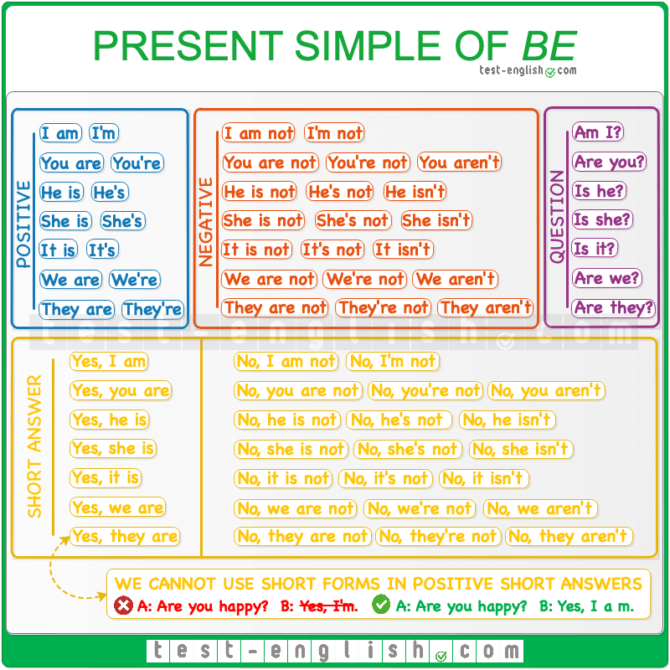

Download full-size image from Pinterest
The present simple of the verb be has three forms:
‣ I am.
‣ He/She/It is.
‣ We/You/They are.

They= people and things
We use he for a man, she for a woman, and it for a thing.
- He‘s a little boy.
- She‘s beautiful.
- I like this TV. It‘s very big.
We use they for people and for things.
- I love Sara and Jonas. They are my friends.
- I love these chairs. They are very beautiful.

Don’t forget the subject
We always need a subject before the verb.
- It is cold.
- Is cold.
- Sally is a wonderful woman.
- Is a wonderful woman.

Contractions or short forms
We use ‘m, ‘s and ‘re with personal pronouns (I, you, he, etc.)
- I’m sad.
- You’re tired.
- She’s from Scotland.
But we can also use ‘s with names.
- Laura’s beautiful.
- London’s an expensive city.

Contractions in short answers
We can only use contractions in negative short answers. Not in positive short answers.
- Yes, I am.
- Yes, I’m.
- Yes, she is.
- Yes, she’s.
- Yes, they are.
- Yes, they’re.

The present simple of be – USE
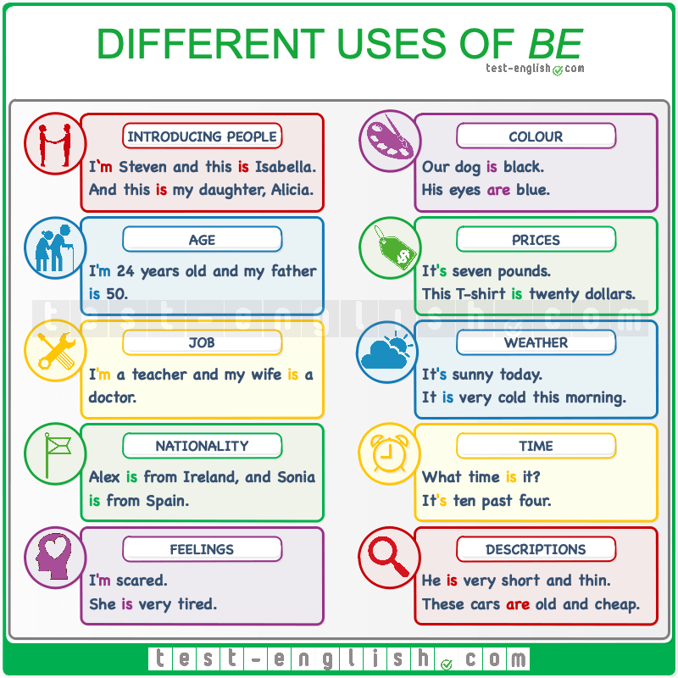

Download full-size image from Pinterest
We use the verb be to talk about:
Who we are: I‘m Steven, and this is Isabella. And this is my daughter, Alicia.
Age: I‘m 24 years old, and my father is 50.
Job: I‘m a teacher, and my wife is a doctor.
Nationality: Alex is from Ireland, and Sonia is from Spain.
Feelings: I‘m scared. She is very tired.
Colour: Our dog is black. His eyes are blue.
Prices: It‘s seven pounds. This T-shirt is twenty dollars.
The weather: It‘s sunny today. It is very cold this morning.
The time: What time is it? It‘s ten past four.
Descriptions in general: He is very short and thin. The cars are old and cheap.

Present simple form

In present simple verbs, we need to use the verb do/does in questions and don’t/doesn’t in negatives.
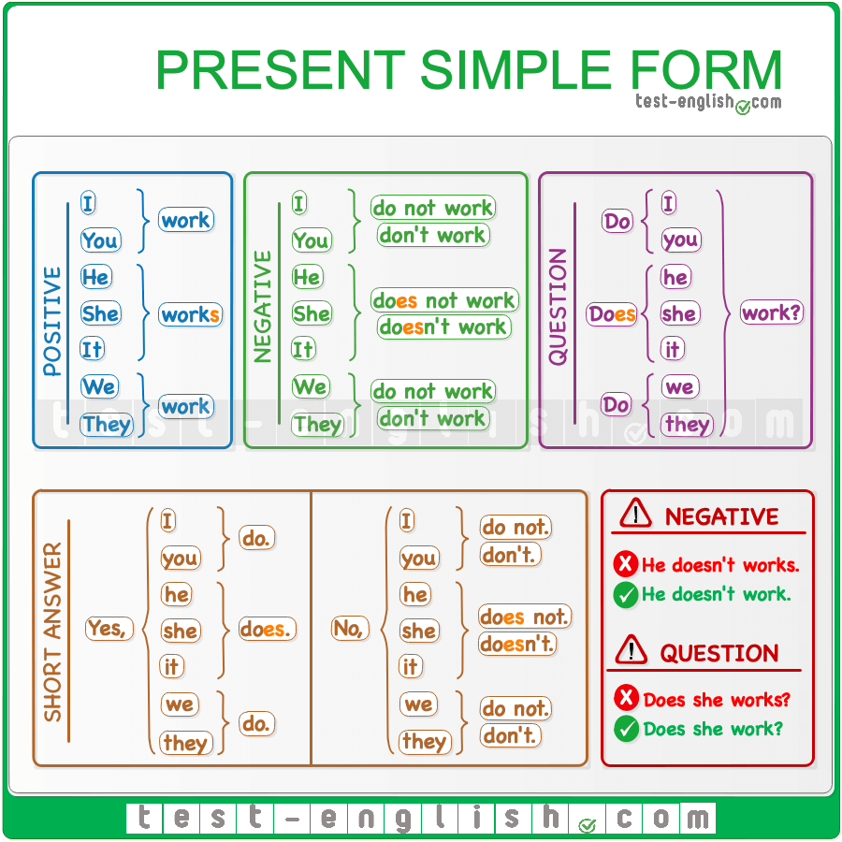

Download full-size image from Pinterest

Spelling of he/she/it
The form is the same for all the other persons except he/she/it. The spelling for he/she/it is different.
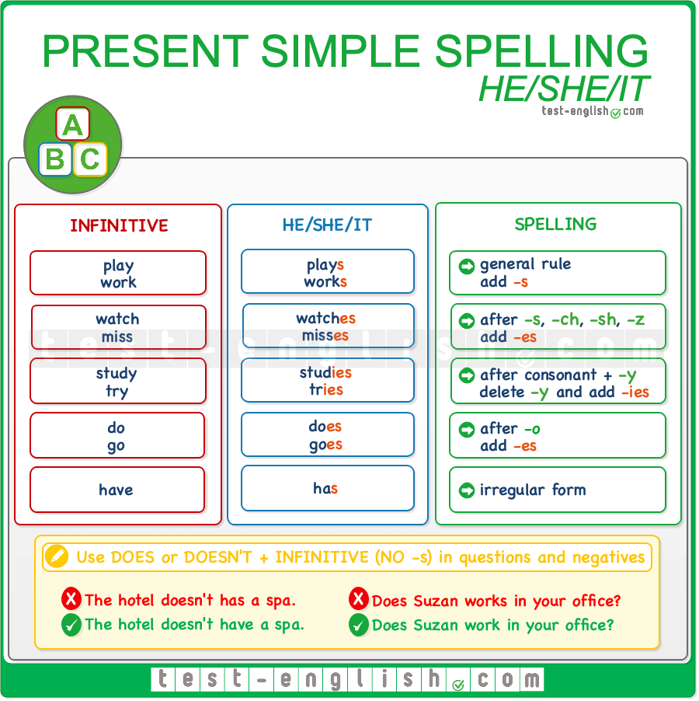

Download full-size image from Pinterest

Present simple use

Habits or actions that happen regularly
We use present simple for habits or actions that we repeat regularly:
- I wash my hair every day.
- I never go to the library.
- I go to the library on Saturdays.

Permanent situations or things that are always or often true
- I don’t drink coffee.
- She’s very tall.
- I have two brothers.
- Water boils at 100 degrees.
- I like soup.

Present continuous: Form

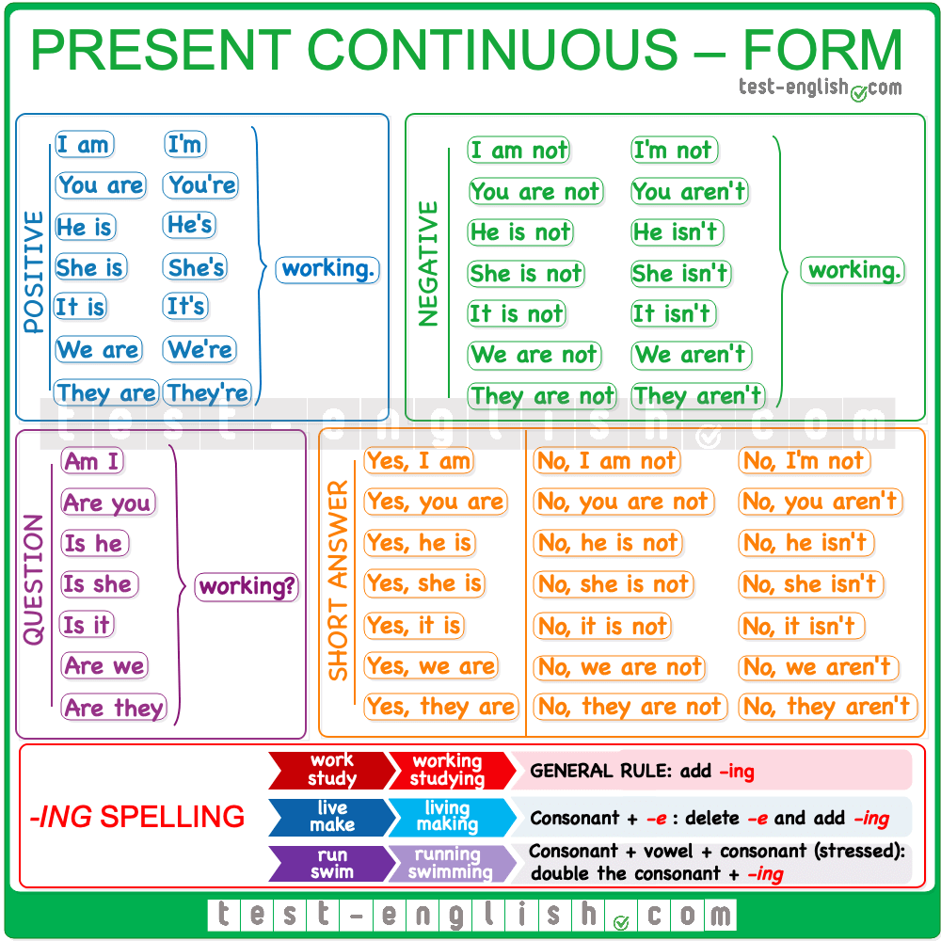

Download full-size image from Pinterest
We form the present continuous with am/is/are + the -ing form of the verb.
- I am writing a book.
- She is listening to the radio.
- They are doing their homework.
The short forms of am/is/are are: ‘m/’s/’re.
- I‘m writing a book.
- She‘s listening to the radio.
- They‘re doing their homework.
The negative short forms of am not/is not/are not are: ‘m not/isn’t/aren’t.
- I‘m not writing a book.
- She isn’t listening to the radio.
- They aren’t doing their homework.
❗ Note that we can use short forms only in negative short answers, but not in positive short answers.
- ‘Are you writing a book?’ ‘No, I’m not/I am not.’
- ‘Are you writing a book?’ ‘Yes, I am.’
- ‘Are you writing a book?’ ‘Yes, I’m.’

Actions happening now
We use the present continuous for things happening now, at the moment of speaking.
- ‘What are you doing?’ ‘I‘m watching TV.’

Actions happening around now
We use the present continuous for temporary things that are happening around now (=not at the moment of speaking but these days, or weeks, etc.)
- I‘m reading a very good book at the moment. (=I’m not reading it at the moment I’m speaking, but I’m reading it these days.)

Now, these days, at the moment, etc.
We use the present continuous with time expressions that mean ‘now’ or ‘around now’: now, at the moment, at present, today, these days, this week, etc.

Present simple or continuous?: Grammar chart

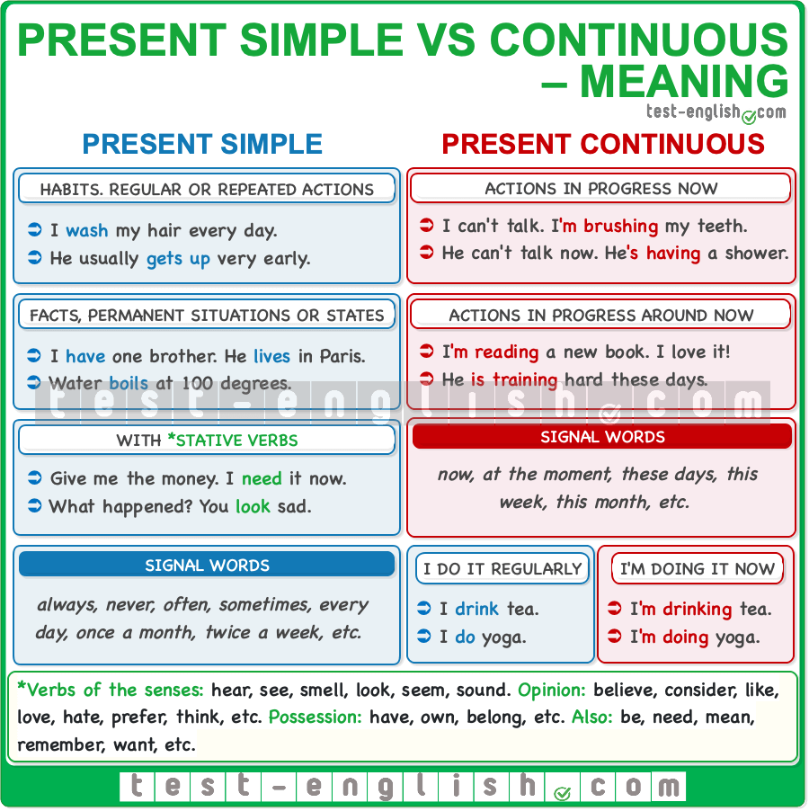

Download full-size image from Pinterest

Present simple
We use the present simple for habits or permanent situations. You can revise the form of the present simple tense here.

Habits or actions that happen regularly
We use the present simple for habits or actions that we repeat regularly:
- I wash my hair every day.
- I never go to the library.
- I go to the library on Saturdays.

Permanent situations or things that are always or often true
- I don’t drink coffee.
- She’s very tall.
- I have two brothers.
- Water boils at 100 degrees.
- I like soup.

Adverbs and expressions of frequency
We use adverbs and expressions of frequency with the present simple to talk about how often something happens.
- We usually order a pizza on Fridays.
- I go running twice a week.

Stative or non-action verbs
Some verbs don’t describe actions. These verbs are called stative or non-action verbs, and we can use these verbs in the present simple but NOT in the present continuous. Some of these verbs are be, have (=possess/own), like, love, hate, prefer, need, want, know, etc.
- They have a new car.
- They are having a new car.
- I like chocolate.
- I‘m liking chocolate.

Present continuous
We use the present continuous for things that are happening now (at the moment of speaking) or for temporary things that are happening around now (these days or weeks, etc.). You can revise the form of the present continuous tense here.

Actions happening now
We use the present continuous for things happening now, at the moment of speaking.
- ‘What are you doing?’ ‘I‘m watching TV.’

Actions happening around now
We use the present continuous for temporary things that are happening around now (=not at the moment of speaking but these days, weeks, etc.)
- I‘m reading a very good book at the moment. (=I’m not reading it at the moment I’m speaking, but I’m reading it these days.)
- What TV series are you watching these days? (=You are not watching it at the moment of speaking, but these days.)

Now, these days, at the moment, etc.
We use the present continuous with time expressions that mean now or around now. Some of these expressions are: now, at the moment, at present, today, these days, this week, etc.

Present simple or continuous?

Usually or now?
We use the present simple for things that we usually do, and we use the present continuous for things that we are doing now.
- I listen to the radio. (=I usually listen to the radio; it’s a habit.)
- I‘m listening to the radio. (=I’m doing it now.)
- I don’t usually watch documentaries, but I’m watching a documentary now.

Temporary or permanent?
We use present simple when a situation is permanent or present continuous when a situation is temporary.
- I work in an office. (=Permanent situation.)
- I‘m working in an office. (=Temporary situation.)
- I live in Edinburgh. (=Permanent situation.)
- I‘m living in Edinburgh. (=Temporary situation.)

What do you do? vs What are you doing?
- What does Erik do? (=What is his job?)
- What is Erik doing? (=What is he doing now, at the moment of speaking?)

Have got: Form

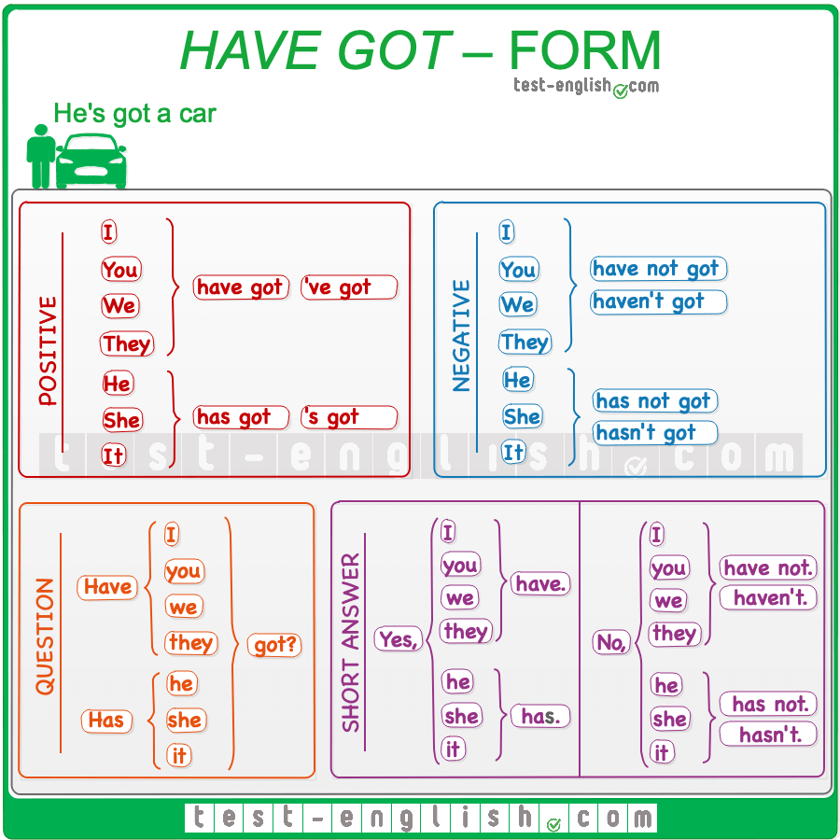

Download full-size image from Pinterest

Have got (British English) = have (American English)
The verb have got is a common form used in the UK, mainly when people are speaking. In the US, people use the verb have.
- I‘ve got a car. = I have a car.
- I haven’t got a car. = I don’t have a car.
- Have you got a car? = Do you have a car?

Be careful with this common mistake!
The verb have got only has a present form (NOT past).
- I had got a car.
- I had a car.
- I hadn’t got a car.
- I didn’t have a car.
- Had you got car?
- Did you have car?

Have got: Use

Possession, family
- She‘s got a nice apartment.
- Have you got a computer?
- I haven’t got any brothers or sisters.

Illnesses
- I‘ve got a headache.
- She‘s got a cold.

Physical descriptions
- He‘s got brown hair and a long nose.
- They‘ve got blue eyes.

Past tenses

Was/were: Form
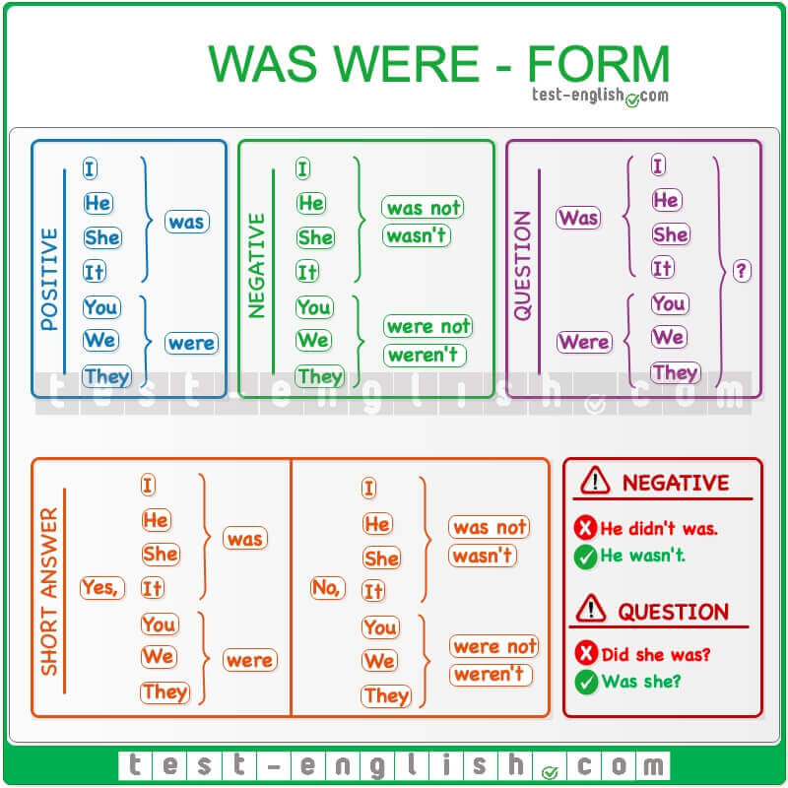

Download full-size image from Pinterest

Was/were
We use was/were as the past simple forms of be. We use was for I/he/she/it and were for you/we/they.
- I was at home yesterday.
- You were late at the meeting.
- She was excited about the party.
- We were tired after the excursion.
- Were they at the conference?

No positive short forms
The negative short forms of was not and were not are wasn’t and weren’t, but there are no short forms of was and were in affirmative sentences.
- Tom was tired, but Susan wasn’t very tired.
- Paul and Tom were happy, but we weren’t happy.

Was/were: Use
Was/were are the past forms of am/is/are. Present: am/is = past: was. Present: are = past: were.
- I‘m happy. ⇒ I was happy. (am ⇒ was)
- She is at her office. ⇒ She was at her office. (is ⇒ was)
- You are late. ⇒ You were late. (are ⇒ were)
We use was/were to talk about the past. We often use past expressions of time: yesterday, last night, last week, two months ago, etc.
- She was in Stuttgart last summer.
- We were late to the party last night.
We use was/were in the expression was/were born. The expression be born is always past (NOT present): was/were born.
- ‘Where were you born?’ ‘I was born in Sweden.’
- ‘Where are you born?’ ‘I am born in Sweden.’
- Mozart was born in 1756.

Past simple regular

We often add -ed to verbs (regular verbs) to make the past simple.
- We often watch a film on Saturday. ⇒ We watched a film last Saturday.
- I live in Barcelona. ⇒ I lived in Barcelona in the 90s.

Spelling of regular verbs
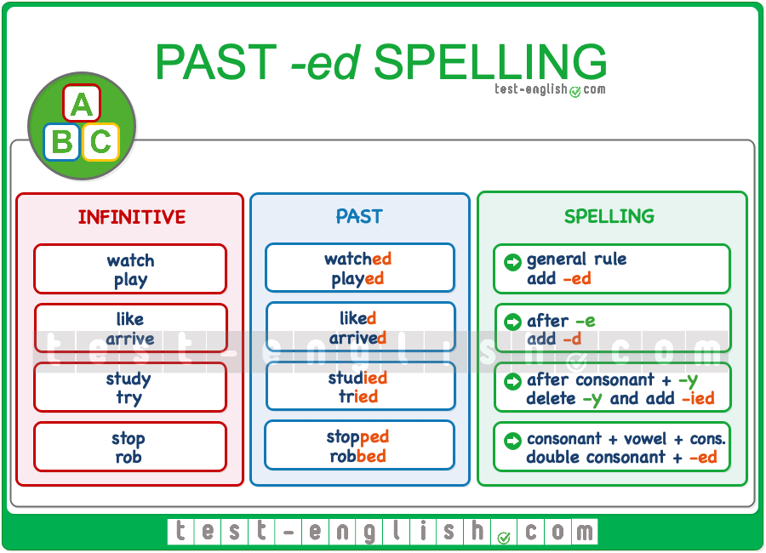

Download full-size image from Pinterest

When do we double the consonant?
We double the consonant when the verb ends in consonant + vowel + consonant. This is always true when the verb is one syllable.
- stop ⇒ stopped, plan ⇒ planned, shop ⇒ shopped, rob ⇒ robbed.
When the verb is two syllables, we only double the consonant when the STRESS is in the last syllable.
- reFER ⇒ referred, preFER ⇒ preferred, reGRET ⇒ regretted
But we do NOT double the consonant when the STRESS is NOT in the last syllable.
- VIsit ⇒ visited, ANswer ⇒ answered.

Past simple irregular
Irregular verbs don’t add -ed to make the past simple. Some very common irregular verbs are:
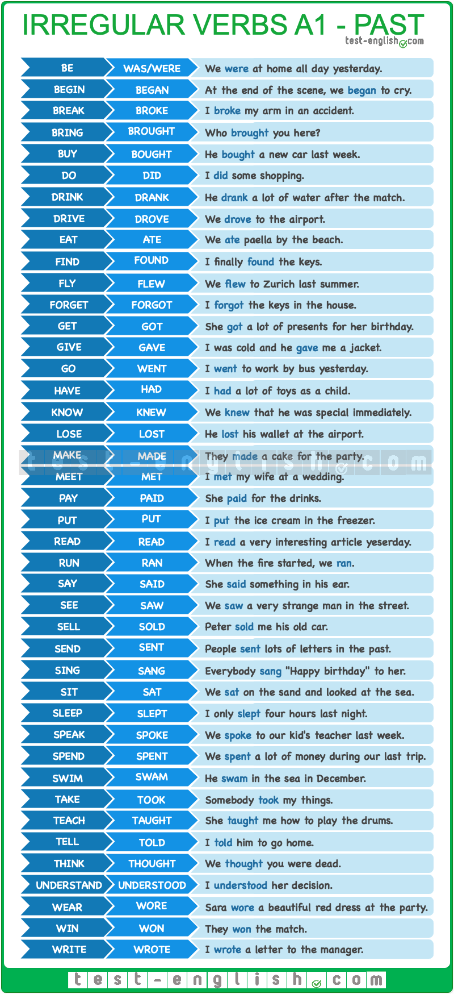

Download full-size image from Pinterest

Past simple: Use

Past finished actions or states
We can use the past simple to talk about past finished actions or states. We know and we often mention when these actions happened with a past time expression: yesterday, yesterday morning, last night, last week, two days ago, five years ago, etc.
- Jessica called me last night.
- Rachel was a very good writer.

Past repeated actions
We can use the past simple to talk about habits or repeated actions that happened in the past but don’t happen in the present. We often use adverbs or expressions of frequency (often, always, every day, etc.).
- When I was a child, I ate sweets every day.
- In school, I always played football during break time.

Past simple negatives and questions

We use did and didn’t to make negatives, questions and short answers in past simple.
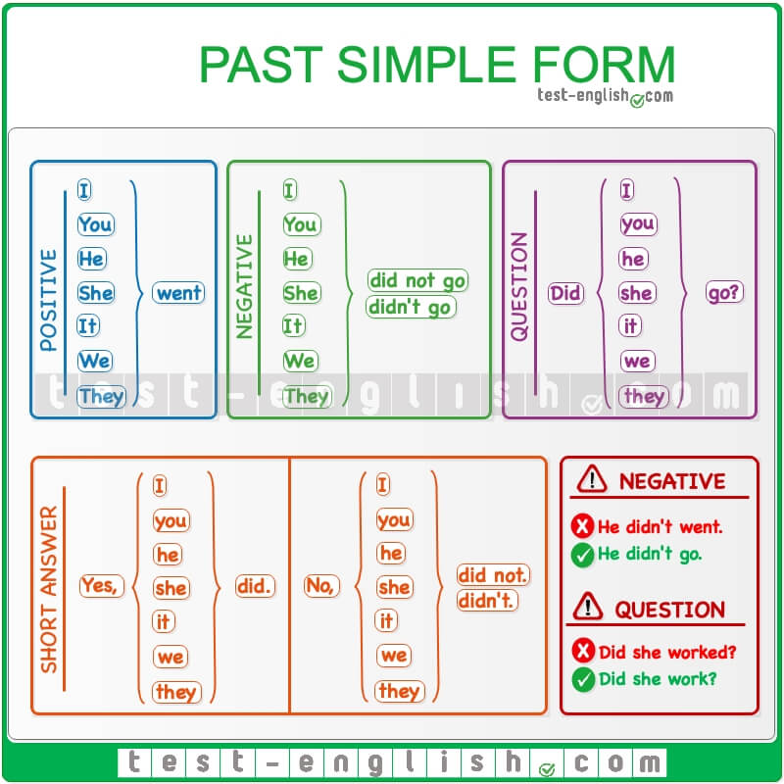

Download full-size image from Pinterest

Word order in questions
Remember that the word order in questions is QWASI: (Question Word), Auxiliary (did), Subject, Infinitive.
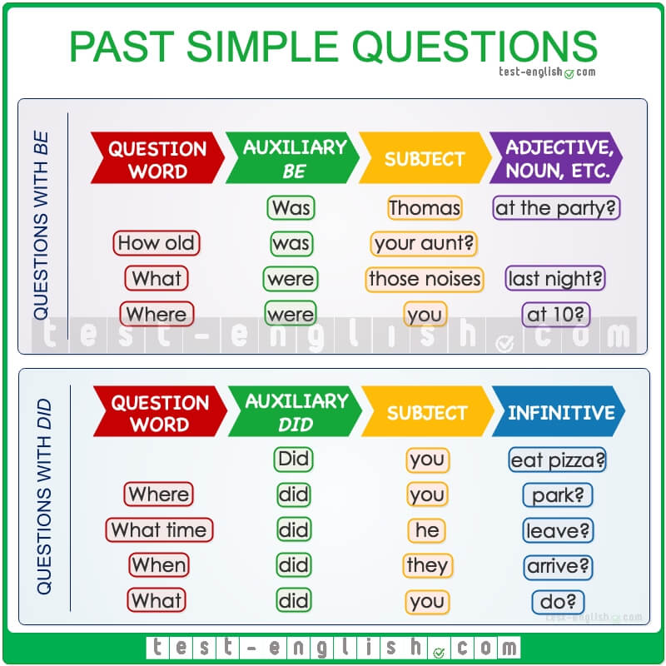

Download full-size image from Pinterest

Infinitive without to
We use did or didn’t with the bare infinitive of the main verb (= infinitive without to).
- I didn’t work yesterday.
- I didn’t didn’t worked yesterday.
- Did you go to the concert?
- Did you went to the concert?

Don’t use did in positive sentences
We use did or didn’t in negatives, questions and short answers, but NOT in positive sentences.
- We stayed home yesterday.
- We did stay home yesterday.
- I went out last night.
- I did go out last night.

Did or was/were?
We use did and didn’t (NOT was/wasn’t or were/weren’t) as the auxiliary verb in negatives and questions in past simple.
- We didn’t eat at 6.
- We weren’t eat at 6.
- Did you do your homework?
- Were you do your homework?
We do NOT use did or didn’t in past simple negatives or questions when the main verb is be.
- They weren’t happy.
- They didn’t be happy.
- Was he at home?
- Did he be at home?

Future

Will: Form

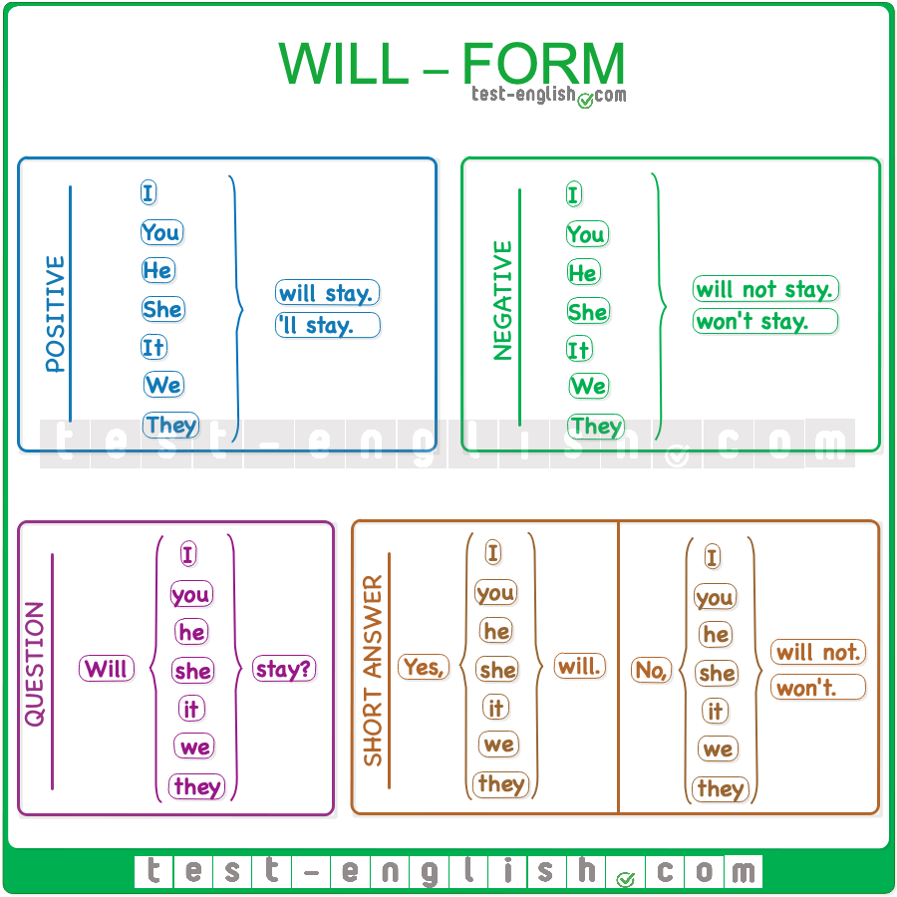

Download full-size image from Pinterest
Will is an auxiliary verb. This means that:
- We use will + infinitive: I‘ll be (or will be) at home next Saturday.
- Will has a negative form: I won’t be (or will not be) at home next Saturday.
- We put will before the subject in questions: Will you be at home next Saturday?
- We use will in short answers: Yes, I will. / No, I won’t (or No, I will not).

Will: Use
We use will to talk about things that we think will happen in the future.
- He will love your new coat.
- They won’t win this match.
🔍 Note that it’s common to use will with the expressions I think, I don’t think, I hope, etc., or also with I’m sure, I’m not sure, perhaps, etc.
- I hope they will arrive soon.
- I don’t think they‘ll win.
- I’m sure you‘ll be fine.
- Perhaps I‘ll be late.
We use will for promises or refusals.
- I will lend her the money.
- I won’t help you.
We use will when we make decisions at the moment of speaking (instant decisions).
- A: There’s no milk in the fridge. B: I’ll go to the shop to buy some more.
- A: This box is very heavy. B: Don’t worry. I’ll help you.

Shall I…? Shall we…?
We use Shall I…? or I’ll when we offer to do things for other people.
- Shall I make some coffee? (=Do you want me to make coffee?)
- I‘ll make some coffee.
We use Shall we…? to suggest doing something.
- Shall we go to the cinema? (=Do you want to go to the cinema?)

Be going to: Grammar chart

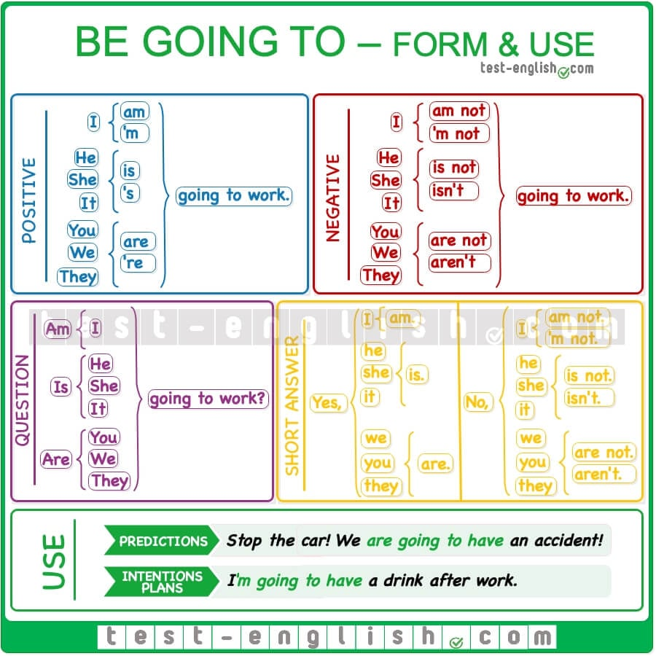

Download full-size image from Pinterest

Be going to: Form
Be going to consists of the present continuous of the verb go (I’m going, you are going, etc.) + to-infinitive form of the main verb.

When the main verb is go
When the main verb is go, we can exclude it if we want.
- I’m going shopping this afternoon. (=I’m going to go shopping this afternoon.)
- We are going to Cyprus next summer. (=We are going to go to Cyprus next summer. )

Be going to: Use

Predictions
We use be going to to talk about something that we see is going to happen (there is present evidence).
- Don’t drive like a crazy man. We’re going to have an accident!
- The doctor said I’m going to have a girl.
- Look at those clouds. It’s going to rain.

Intentions or plans
We use be going to for intentions or plans (decisions taken before the moment of speaking).
- ‘Why are you undressing?’ ‘Because I’m going to go for a swim.’
- We are going to have a drink after work. Do you want to come?

Future time expressions
We often use be going to with future time expressions (tomorrow, next week, etc.).
- We are going to play cards tonight.
- She’s going to study biology next year.

Modals, the imperative, etc .

Can, can’t: Grammar chart

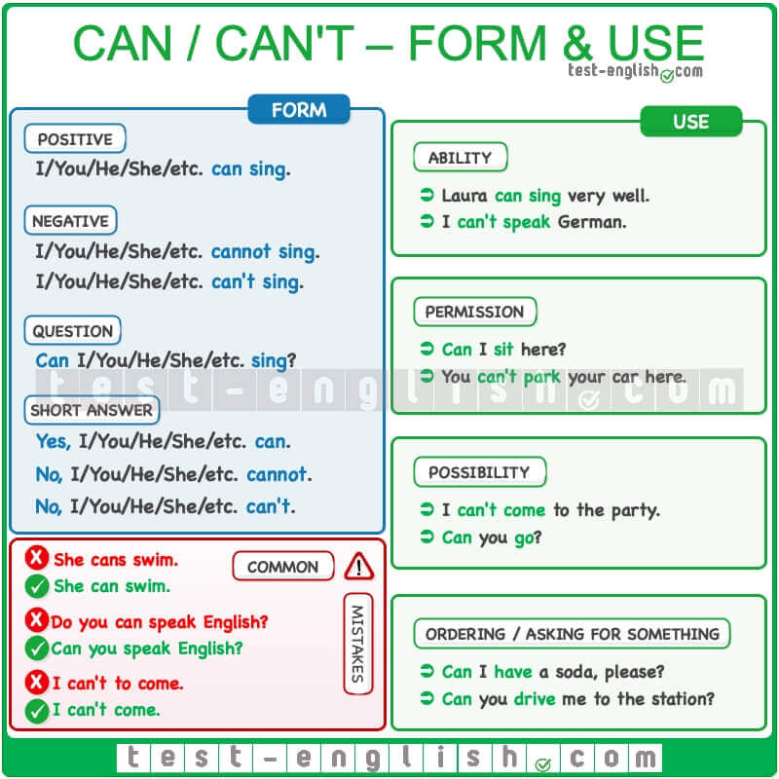

Download full-size image from Pinterest

Can, can’t: Form

Infinitive without to
We use can + infinitive without to.
- I can swim.
- I can to swim.
- We can’t come.
- We can’t to come.

Don’t use -s after he/she/it
We don’t add -s after he/she/it. We use can for all persons.
- He can swim.
- He cans swim.

Don’t use do/don’t
Can is an auxiliary verb and has a negative and interrogative form. We don’t use do/don’t to make questions and negatives.
- Can you swim?
- Do you can swim?
- He can’t swim.
- He don’t can swim.

Can, can’t: Use

Ability
We use can/can’t to talk about ability in the present (=things that we know how to do).
- Laura can sing very well.
- I can’t speak German.

Possibility
We use can/can’t to ask for permission or to say if something is possible or not.
- Can I sit here?
- You can’t vote if you aren’t 18 years old.
- I’m sorry, but I can’t come to the party.

Ask for something
We use can/can’t to ask for something and to order in bars, restaurants, shops, etc.
- Can you lend me some money?
- Can I have some water, please?
- Can I have a burger and a soda?

The imperative: Grammar chart

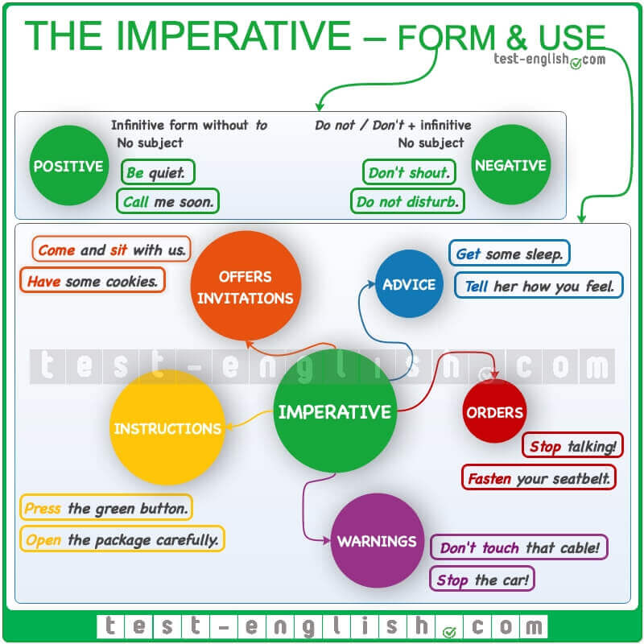

Download full-size image from Pinterest

Form
The form of the verb used for the imperative is the base form of the verb (=the infinitive without to). There is no subject.
The negative imperative is made with do not or don’t + infinitive (no subject).

Use
You can use the imperative to:

Give instructions
- Open the package carefully.
- Connect the cable to the plug.

Give orders
- Fasten your seatbelt.
- Stop talking!
- Run!

Offer something or invite someone to something
- Have some cookies.
- Come and sit with us.

Give advice
- Get some sleep.
- Tell her how you feel.
- Go and have fun.

Give warnings
- Don’t touch that cable.
- Please, Stop the car!

Let’s

Make suggestions
You can use the form let’s + verb or let’s not + verb to make suggestions.
(+) It’s very hot today. Let’s go to the swimming pool.
(-) Let’s not go out today. I’m very tired.

Would you like…?

We use Would you like…? to offer something or to invite somebody to do something. Would you like…? = ‘Do you want…?’
- Would you like some cake? (=Do you want some cake?)
- Would you like some coffee?
- Would you like to go to the cinema? (=Do you want to go to the cinema?)
- Where would you like to go?

I’d like
We use I’d like (=I would like) to talk about something that we want or something that we want to do.
- I’d like some water, please. (=I want some water.)
- I’d like more information about this product.
- I’d like to go to the zoo. (=I want to go to the zoo.)
- I’d like to have a lemonade.

Like
We use like + things or people to say that we think these things or people are nice or good.
- I like coffee. (=I think coffee is good.)
- I like John. (=I think John is nice.)
We use like + -ing verb to say that we enjoy doing something.
- I like dancing. (=I enjoy dancing.)
- I like going to the cinema. (=I enjoy going to the cinema.)
We use do in questions.
- Do you like coffee?
- Do you like going to the cinema?

Like vs Would like
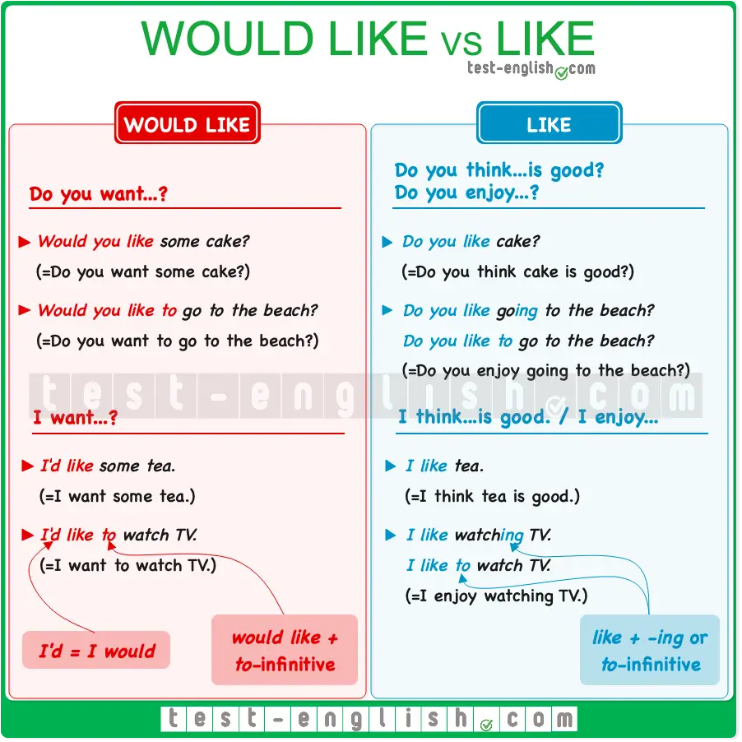

Download full-size image from Pinterest
Compare the following sentences:
- I like tea. (=I think tea is good.)
- I’d like some tea. (=I want some tea.)
- Do you like tea? (=Do you think tea is good?)
- Would you like some tea? (=Do you want some tea?)
We use like + -ing verb or + to-infinitive and would like + to-infinitive. Compare:
- I like going to the cinema. (=I enjoy going to the cinema.)
- I’d like to go to the cinema. (=I want to go to the cinema.)
- Do you like going to the cinema? (=Do you enjoy going to the cinema?)
- Would you like to go to the cinema? (=Do you want to go to the cinema?)

-ing and the infinitive

Verbs + -ing

Some verbs in English are followed by another verb in the -ing form. The most common of these verbs are verbs of liking and disliking: love, like, enjoy, don’t mind, don’t like, hate. If we use another verb after these verbs, it often takes the -ing form.
- I love going to the gym.
- I like reading.
- I enjoy travelling.
- I don’t mind cooking.
- I don’t like doing homework.
- I hate getting up early.
The second verb is in the -ing form in the past, too.
- When I was a child, I hated going to school.
- When I was a child, I hated went to school.

-ing spelling
You can check the spelling of the -ing form of the verbs in the table below.
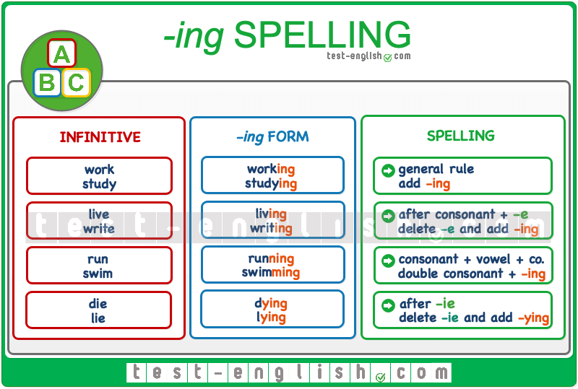

Download full-size image from Pinterest

Verbs + to-infinitive
Many verbs in English are followed by to-infinitive. Some of these verbs are forget, hope, learn, need, offer, plan, remember, start, want and would like.
- I forgot to turn off the light.
- I hope to see you soon.
- I‘m learning to drive.
- We need to arrive early.
- She offered to help us.
- We are planning to go to France.
- Remember to lock the door.
- I want to go home.
- I would like to buy a new computer.
The second verb takes the to-infinitive form in the past too.
- I wanted to go home.
- I wanted to went home.

Would like
The verb would like (or ‘d like) is different from like. We use would like + to + infinitive, and we normally use like + -ing verb to talk about general preference. You can learn more about this topic here.
- I‘d like to study English.
- I like studying English.
The meaning is also different.
- I‘d like to study English. (=I want to do it.)
- I like studying English. (=I enjoy it.)
We use the question would you like… when we offer or suggest something.
- Would you like a cup of coffee?
- Would you like to dance with me?

Articles, nouns, pronouns, and determiners.

A/an, plurals – Grammar chart

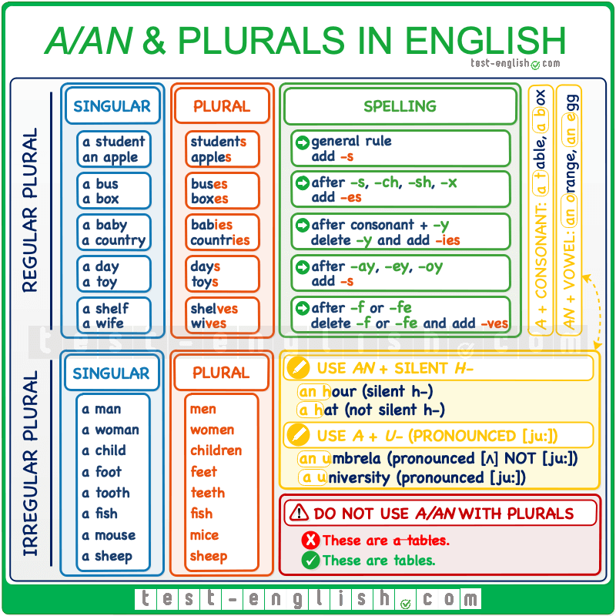

Download full-size image from Pinterest

A/an
We use a/an with singular nouns.
- This is a table.
- It’s an orange.
We use a with nouns beginning with a consonant, and we use an with nouns beginning with a vowel (a, e, i, o, u).
- Give me an apple.
- There is an elephant in the zoo.
- It’s an amazing experience.
We also use an with nouns beginning with h if the h is not pronounced. But we use a if the h is pronounced.
- Give me an hour. (The h is not pronounced in hour.)
- I want to buy a hat. (The h is pronounced in hat.)
We use a and NOT an with nouns beginning with u when it is pronounced /ju:/, like university.
- Is there a university in this city?
- I wear a uniform.

Plurals in English

Do not use a + plural
We do NOT use a/an with plural nouns.
- These are tables.
- These are a tables.

Regular plurals
We add -s to make plural nouns in English. Sometimes we need to add -es, -ies or –ves. Check the spelling in the grammar chart above.

Irregular plurals
Some words have irregular plurals and do NOT add -s to make their plural form.

A/an, the, no article: Grammar chart

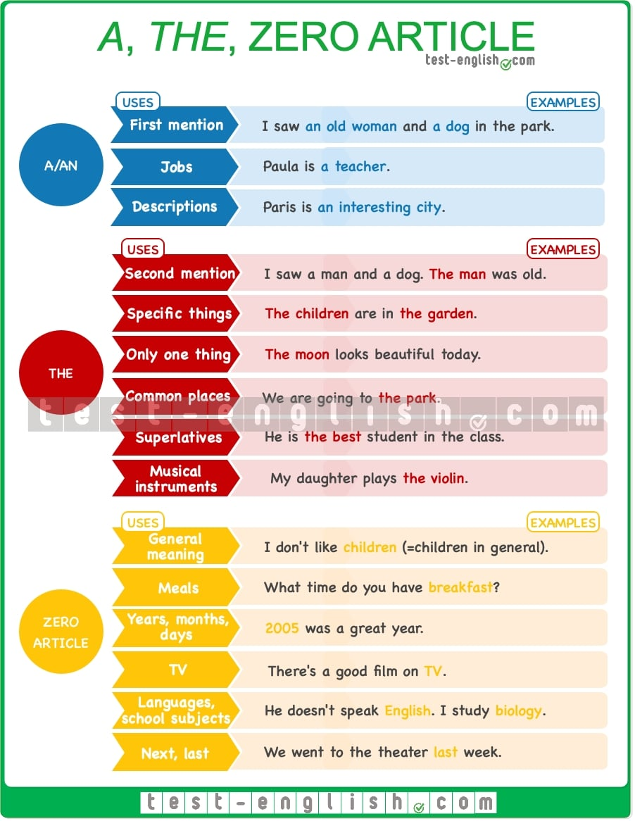

Download full-size image from Pinterest

Use a/an

First mention
We use a/an when we mention something for the first time.
- I saw an old woman with a dog in the park.

Jobs and descriptions
We use a/an to talk about people’s jobs or to say what kind of person or thing something/somebody is.
- Paula is a teacher.
- Paris is an interesting city.
- When I was a teenager, I enjoyed sleeping.
❗ Note that you cannot use singular countable nouns alone (without a, the, my, etc.)
- I don’t have driving license.
- I don’t have a driving license.
- This hotel doesn’t have spa.
- This hotel doesn’t have a spa.

Use the

Second mention
We use the when we mention something for the second time.
- A man and a woman sat in front of me. The man was British, but I think the woman wasn’t.

Specific things
We use the to talk about specific things or people –when it’s clear which things or people we are talking about.
- ‘Where are the kids?’ ‘They’re in the garden.’ (=We know which kids and which garden.)
- Can you open the door? (=We know which door.)

There is only one
We use the when there’s only one of something.
- This company is very profitable. The manager must be really good.
- I’d like to live in this country, but not in the capital.
- The moon looks beautiful today.

Common places in town
With places in a town where we commonly go (the park, the cinema, the doctor, etc.)
- I’m going to the bank.
- I found Peter at the station.
- I’m at the library.

Superlatives
We use the before superlative adjectives.
- This is the best restaurant in town.

Musical instruments
We use the before names of musical instruments.
- Margaret plays the guitar and I play the flute.

Use no article

General meaning
We do not use an article before plural or uncountable nouns to talk about something in general.
- I don’t drink milk.
- Women drive more cautiously than men.
Compare:
- I love music. (=Music in general.)
- I loved the music at the party. (=Specific music.)
- Children are often difficult. (=Children in general.)
- They are a nice family. The children are very funny. (=The children in that family.)

Meals
We do not use an article before the names of meals: breakfast, lunch, or dinner.
- Dinner is served at 8.
- I always have breakfast with my children.

Years, months and days
We do not use an article before names of years, months and days of the week.
- Friday is my favourite day of the week.
- I think 2020 will be an excellent year.

TV
We do not use an article with TV (when used as a broadcasting service, NOT as an appliance)
- I saw it on TV.
- I don’t watch TV.
❗ But: Turn off the TV. I’ve bought a new TV.

Names of languages and school subjects
We do not use an article before the names of languages and school subjects.
- He doesn’t speak English.
- I study biology.

Next, last
We do not use an article before next and last + time expression (when they mean before or after now).
- The meeting is next Thursday.
- I saw him last week.
❗ Compare:
- Last year we spent one week in London (Last year= the year before now).
- We really loved London. The last day we were really sad. (The last day= the last day of that trip. NOT the day before now)

This/these= here, that/those= there

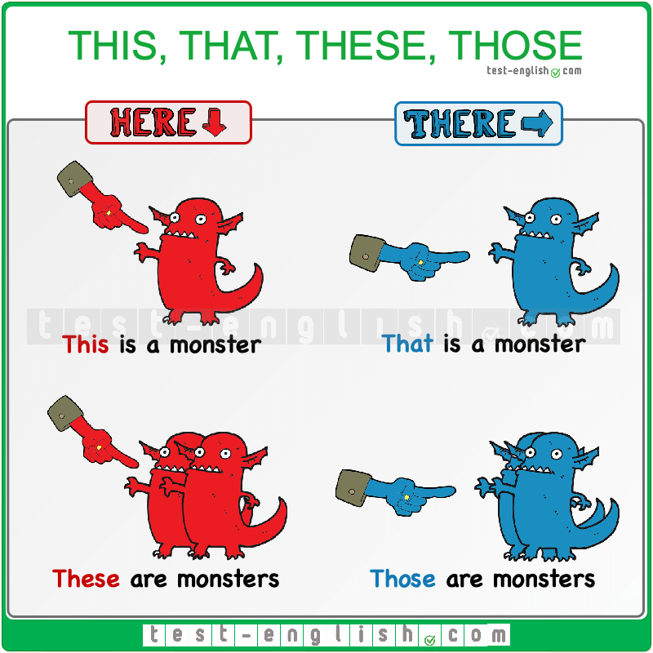

Download full-size image from Pinterest

This, these (here)
We use this and these for things that are here (near). This is singular and these is plural.
- This is my new watch.
- These are my sisters Anna and Jenny.

That, those (there)
We use that and those for things that are there (not near). That is singular and those is plural.
- That man is very strange.
- I need those boxes over there.

With a noun or without a noun
We can use this, that, these, those with a noun (this box, that car, etc.) or without a noun.
- This watch is very expensive.
- I like that woman in the park.
- Who is that? (= that person)
- ‘What are those?’ ‘They are old pictures.’

This is John (introductions and on the phone)
We use this is when we introduce people and on the telephone.
- Hi, this is Tim. (Tim on the telephone)
- Laura: ‘Hi, Sara. This is my friend Paul.’ Sara: ‘Hi, Paul. Nice to meet you.’

Possessive adjectives and subject pronouns

Form
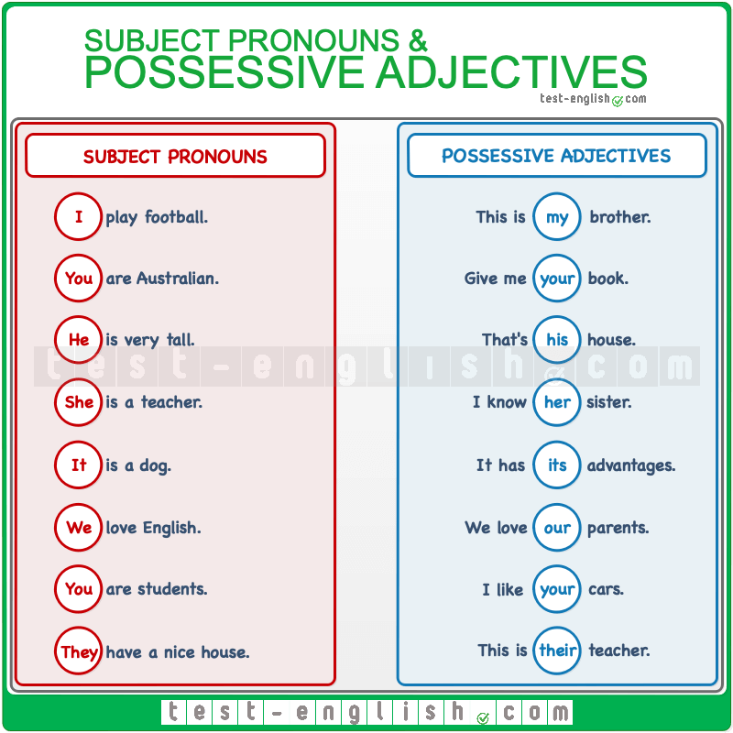

Download full-size image from Pinterest

Use

I + verb / My + noun
We use subject pronoun + verb, and we use possessive adjective + noun.
- These are Susan and Thomas; they are from Ohio. And that’s their house.
- I love my friend Sheila.

Possessive adjectives are always singular
Adjectives in English have no plural form. Possessive adjectives are always singular.
- These are their suitcases.
- These are theirs suitcases.

It/its for things, they/their for people and things
We use he/his and she/her for people, and we use it/its for things. But in the plural, we use they/their for people and things.
- The hotel has its own spa. It is a relaxing place.
- I like those chairs, they are beautiful. But their legs are too long.

It’s for time and weather
We use it’s (=it is) to talk about the time or the weather.
- It’s very windy today, but it’s sunny.
- ‘What time is it?’ ‘It’s three o’clock.’

Its or it’s?
Its = possessive adjective. It’s = it is (subject + verb be)
- Look at that dog. It’s beautiful. I like its hair.

Object pronouns vs subject pronouns: Me or I, She or Her?

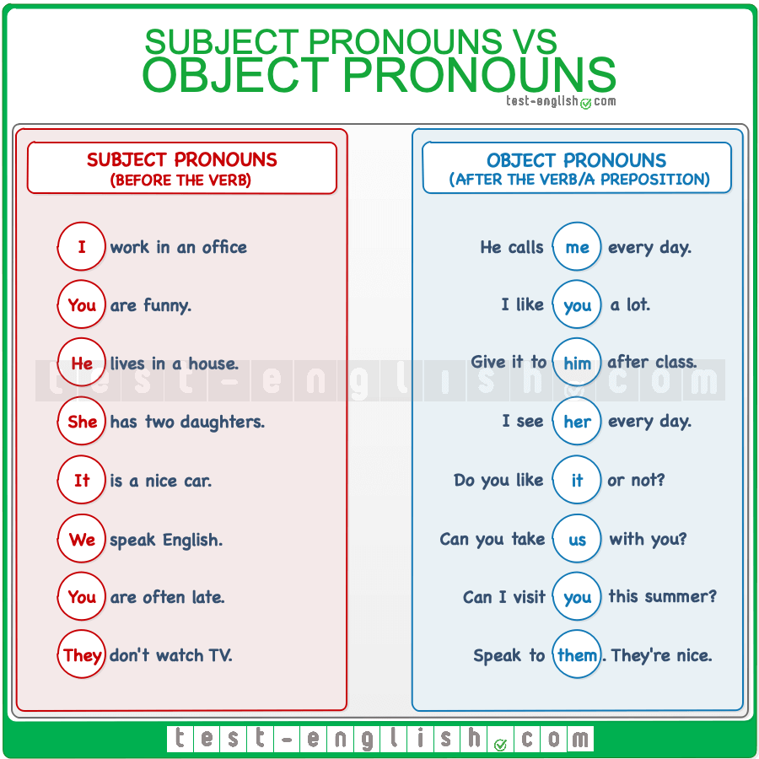

Download full-size image from Pinterest

Subject pronouns

Subject: Before the verb
Subject pronouns are the subject of a verb. They go before the verb.
- I like your dress.
- You are late.
- He is my friend.
- It often rains.
- She is on holiday.
- We live in England.
- They come from London.

Object pronouns

Object: After the verb
Object pronouns are the object of a verb. They go after the verb.
- Can you help me , please?
- I can see you.
- She doesn’t like him.
- I see her every Monday.
- We can see him, but he can’t see us.

After preposition
We use object pronouns after prepositions.
- She is there for me.
- I’ll get it for you.
- Give it to him.
- Can you listen to her?
- Don’t take it from us.
- I want to speak to them.

Countable nouns

Countable nouns are nouns that we can count: car, house, book, etc. We can say one car, two cars, three cars, etc.
Countable nouns have singular and plural forms: a car/cars, a house/houses, a book/books, etc.

A/an + singular countable noun
We CANNOT use a singular countable noun without a determiner like a/an, the, my, your, her, etc.
- I have car.
- I have a car.
- When I was child.
- When I was a child.

Uncountable nouns
Uncountable nouns are nouns that we cannot count: money, milk, rain, etc. We cannot say one money, two moneys, etc. So, uncountable nouns do not have a plural form; they only have a singular form: money, milk, rain, etc.

Do NOT use a/an
We cannot use a/an + uncountable noun. A/an means ‘one’, and we cannot count uncountable nouns.
- I need a money.
- I need money.
- We need to buy a sugar.
- We need to buy sugar.

Types of words that are uncountable
Some types of words that are typically uncountable are:
Food, drinks and liquids: cheese, bread, pasta, coffee, milk, petrol, fuel, etc.
Materials: iron, wood, metal, paper, plastic, etc.
Abstract ideas and feelings: information, advice, strength, time, love, excitement, etc.
Illnesses: diabetes, Alzheimer’s, cancer, etc.
Languages: English, French, Spanish, etc.

Uncountable in English but not in other languages
Some nouns are uncountable in English, but they are countable in other languages. Some of them are advice, news (it ends in -s, but it’s a singular word), furniture, luggage, baggage, bread, cheese, toast, etc.

Nouns that can be countable and uncountable
Some nouns can be countable and uncountable because they can refer to a unit or to ‘mass’ or ‘material’. Compare:
- Yesterday I had two coffees. (= two cups of coffee)
- I love coffee. (= the liquid that we drink)
- I found one hair in my soup. (one single hair)
- She has beautiful hair. (= the mass of hair on her head)

A/an, some, any
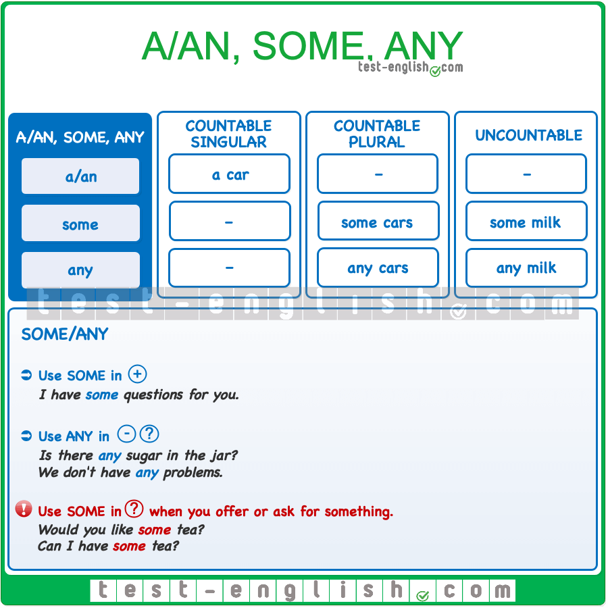

Download full-size image from Pinterest

A/an
We use a/an + singular countable noun.
- I have a new car.
- She has a brother and a sister.
We cannot use a/an before a plural noun or an uncountable noun.
- We need to buy a sugar.
- I need to buy sugar.
- We saw a very beautiful places.
- We saw very beautiful places.

Some/any
We use some and any before countable plural nouns or uncountable singular nouns.
- He gave me some coins.
- He didn’t give me any coins.
- He gave me some money.

Some
We use some in positive sentences.
- We cooked some cookies.

Any
We use any in negative sentences and questions.
- She didn’t send me any messages.
- Have you got any brothers or sisters?
❗ But we use some in questions when we are asking for something, or we are offering something.
- Can I have some tea? (=I’m asking for some tea.)
- Would you like some tea? (=I’m offering you some tea.)

Grammar chart: Much, many, a lot of, a little, a few, no, any, none

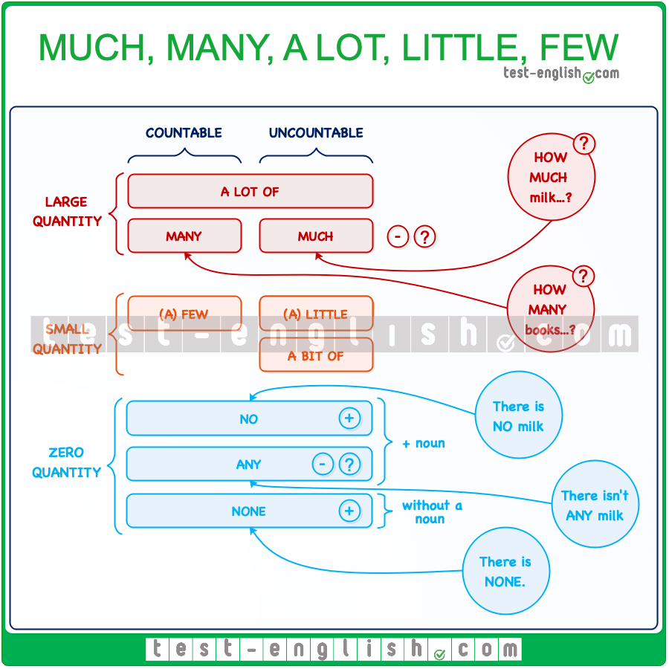

Download full-size image from Pinterest

Much/many

Many for countable, much for uncountable in (?) (-)
We use much/many in negative sentences and questions. We use many before plural countable nouns and much before uncountable nouns. We don’t normally use them in affirmative sentences.
- There isn’t much coffee in the jar.
- Were there many people at the party?

How much/how many
We use how many + plural nouns and how much + uncountable nouns to ask about quantity. You can review countable and uncountable nouns here.
- How many books did you read last semester?
- How much coffee do you drink every day?
We can also say How much is it? to ask about the price of an item.
- ‘How much is it?’ ‘It’s 43 pounds.’
- ‘How much are the trousers?’ ‘They’re 58 pounds.’

A lot (of)

Before both countable and uncountable
We use a lot of before both plural countable and uncountable nouns to talk about a large quantity. We normally use a lot of in positive sentences.
- She spends a lot of time watching TV.
- We had lots of good moments together.
We can say quite a lot of to talk about medium quantity.
- With my new job, I have quite a lot of free time.
It is also possible to use a lot of in negative sentences and questions.
- Do you eat a lot of sugar?
- I don’t read a lot of books.

Of before noun; of at the end of sentence
We must always use a lot of including of before a noun. However, we can use a lot (without of) at the end of a sentence or in short answers.
- ‘How many beers did you have?’ ‘I don’t know; I had a lot.’
- I like her a lot.
- ‘How much coffee did you have?’ ‘A lot.’

A few/a little

A few for countable; a little for uncountable
We use a few before plural countable nouns and a little before uncountable nouns in affirmative, negative and interrogative sentences to talk about a small quantity.
- I have to do a few things this afternoon.
- I always put a little milk in my tea.

Not many, not much
We can also use not many + plural countable or not much + uncountable nouns. The meaning is similar.
- I don’t have to do many things this afternoon.
- I don’t put much milk in my tea.

No/not…any/none
When we want to talk about zero quantity, we can use no + noun or not…any + noun. The meaning is the same.
- I have no time today.
- I don’t have any time today.
In short answers, we use none.
- ‘How much time do you have?’ ‘None.’

Whose, possessive ‘s: Whose is this? It’s Mike’s

Possessive ‘s: Use and form
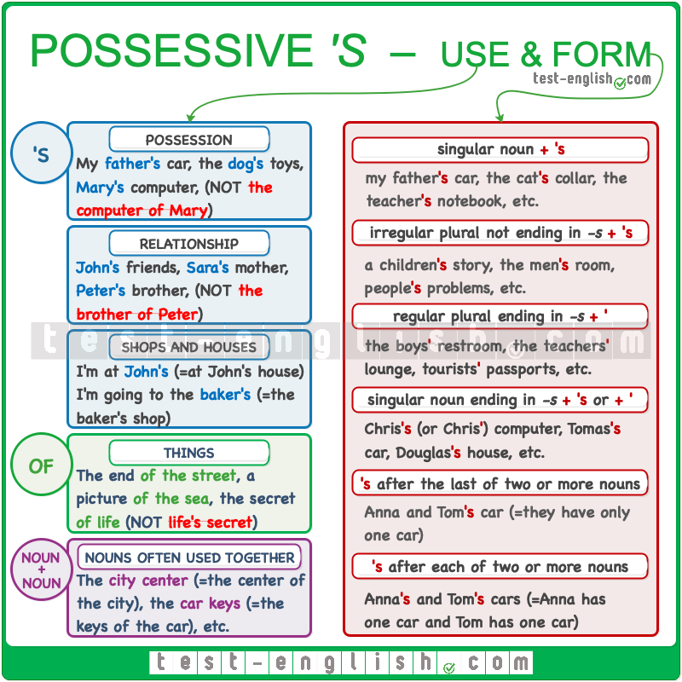

Download full-size image from Pinterest

Possessive ‘s: Use
We use ‘s to show that something belongs to a person (or a pet) or to talk about relationships between people.
- This is Peter‘s father.
- This is the father of Peter.
- Peter and Mary‘s car is red.
- My cat‘s ears are white.
We also use the possessive ‘s to talk about shops and houses.
- I am at John‘s. (= at John’s house)
- I need to go to the chemist‘s. (= the chemist’s shop)

Possessive ‘s: Form
Singular noun + ‘s
- Anna’s clothes, Chris’s wife, the student’s books, etc.
Plural noun ending in -s + ‘ (apostrophe)
- The students’ books, the boys’ toys, the teachers’ lounge, etc.
Irregular plural noun (NOT ending in -s) + ‘s
- The children’s toys, men’s clothes, etc.
When one thing belongs to two or more people, add ‘s only after the last noun.
- Paul and Katherine’s house, Anna and George’s car, etc.
When we have two or more people, and each person has one thing, we add ‘s after each person.
- Anna’s and George’s cars (Anna’s car and George’s car), Sally’s and Tim’s computers (Sally’s computer and Tim’s computer).

Possessive of
We use of and NOT ‘s when we talk about things (and not people or pets).
- the end of the street
- the street‘s end
- a picture of the eclipse
- the eclipse‘s picture
- the man of the match
- the match‘s man

Compound nouns: the city centre
With nouns that are used together very often, we often use them together without of and without ‘s
- a school bus
- the city centre
- the car key

Whose

When do we use whose?
We use the question word whose to ask about possession. There are two possible forms:
whose + noun
- Whose car is this?
- Whose books are those?
whose without a noun
- Whose is this car?
- Whose are those books?
When we answer with the possessive ‘s, we can also use ‘s + noun or ‘s without a noun.
- Whose is this car?
- It’s John‘s car
- It’s John‘s.

Whose vs who’s
Whose = possession (of who)
Who’s = who is
- Whose car is this?
- Who’s car is this?
- Who’s that man in the lobby?
- Whose that man in the lobby?

there and it

There is, there are: Use

We use there is, there are to say that something exists.
- There is a lot of noise.

Where something is
We often use there is, there are to say where something is.
- There is a good restaurant at the end of the street.
- There are some keys in that box.

When something happens
We can also use there is, there are to say when something happens.
- There is a concert tonight.
- There are a lot of storms in summer.

A, some, any
We often use there is, there are + a, some, any.
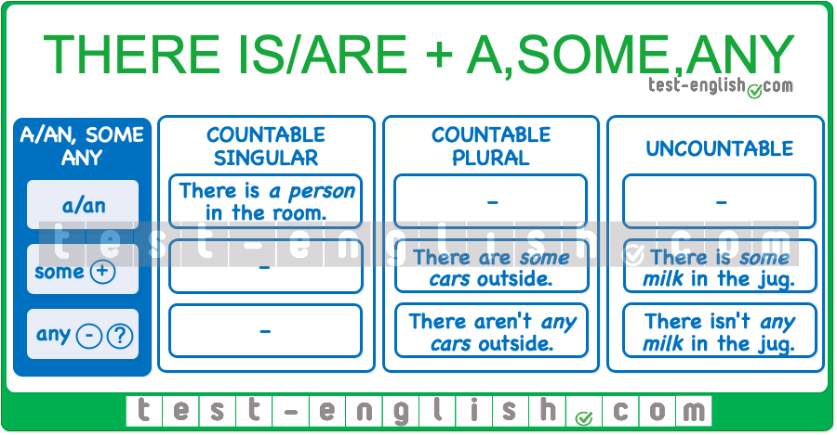

Download full-size image from Pinterest

There is + singular / there are + plural
We use there is + singular noun, and there are + plural noun.
- There is a new teacher in the school.
- There are some problems that we need to solve.
We use there is + a list of things if the first noun after there is is singular.
- In the room, there is a bed, a wardrobe and two chairs.

There is, there are, there was, there were: Form
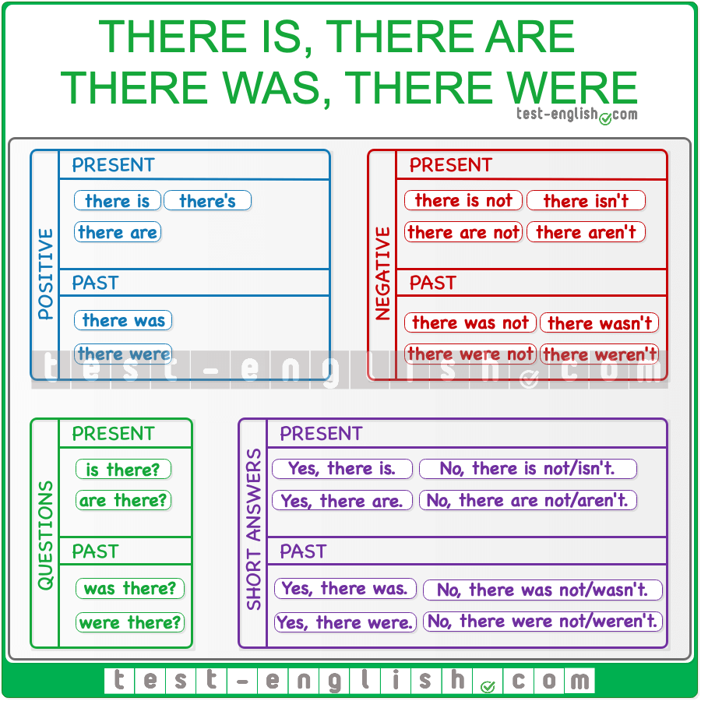

Download full-size image from Pinterest

Present and past
The past form of there is, there are is there was, there were.
- There is a car in the street. ⇒ There was a car in the street.
- There are some cars in the street. ⇒ There were some cars in the street.

Short forms
The short form of there is is there’s, but we don’t use a short form of there are. There’s is not used in short answers.
- There’s a new secretary in the office.
- There are two bathrooms in this house.
There are no short forms for there was/there were.
In negative sentences, we often use the short forms there isn’t/there aren’t and there wasn’t/weren’t.
- There isn’t any bread left. We need to buy more.
- There aren’t any cookies in the jar.

There or It

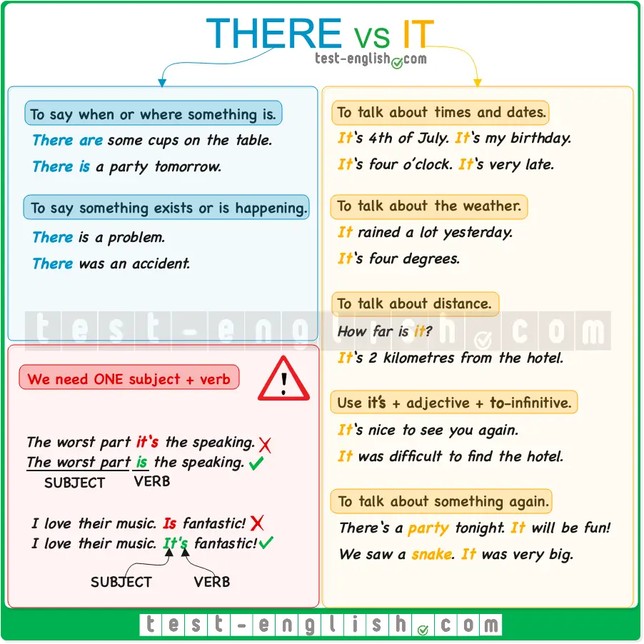

Download full-size image from Pinterest

There
We use there to say when or where something is.
- There are some dirty cups on the table.
- There is a party tomorrow.
We use there to say that something exists or is happening.
- There is a problem.
- There was an accident.
Note that we use there the first time we mention something. If we talk about the same thing again, we use it or they.
- There are some cups on the table. But they are dirty.
- There was an accident. It was horrible.

It
We use it to talk about something again in the conversation.
- There is a party tomorrow. It will be fantastic!
- We saw a snake in the forest. It was very big.
We use it to talk about times and dates.
- It‘s my mum’s birthday today.
- Let’s go home. It‘s very late.
- It‘s four o’clock.
We use it to talk about the weather.
- It‘s very windy.
- It‘s a nice day.
- It rained a lot yesterday.
- It‘s four degrees.
We use it to talk about distance.
- How far is it?
- It‘s not very far.
- It‘s a long way to the nearest petrol station.
- It‘s 2 kilometres from the hotel to the station.
❗ Note that we use far in negative sentences and questions, and we use a long way in affirmative sentences.
We use it’s + adjective + to-infinitive.
- It’s nice to see you again.
- It was difficult to find the hotel.

Be careful with these common mistakes!
- I think the worst part of the exam it’s speaking.
- I think the worst part of the exam is speaking.
We do NOT use it when the subject of the verb is in the sentence. In the sentence above, the subject of is is ‘the worst part of the exam’.
- I love their music. Is fantastic!
- I love their music. It’s fantastic!
Don’t forget to use it when you mention something again in the conversation.

The difference between this and it

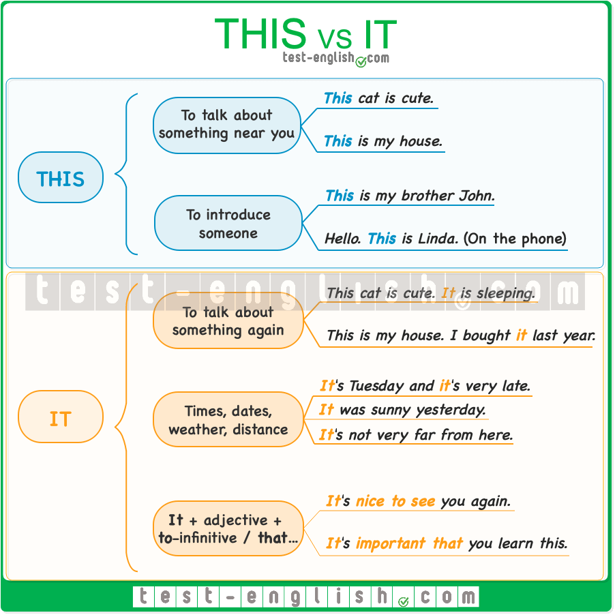

Download full-size image from Pinterest

When do we use this?
You can use this to talk about something near you. It is like pointing your finger at something in front of you.
- This cat is cute. (The cat is right there with you.)
- This is my house. (The house in front of you.)
- I think this jacket is perfect for you.
You can also use this to introduce a person to another one or to introduce yourself on a phone call.
- This is my brother John.
- Hello, this is Linda. (On the phone)
The plural form of this is these.
- These are my brothers, John and Edward.

When do we use it?

To talk about something again
We use it to talk about something that we mentioned, or that is known. It is a pronoun, like he or she, but we use he or she to talk about people, and we use it to talk about objects or animals.
- This cat is cute. It is sleeping.
- This is my house. I bought it last year.
Apart from objects or animals, we can also use it to refer to a situation or idea mentioned before.
- There was a storm, and they cancelled the concert. It was a disaster. (It refers to the storm and the cancelling of the concert)

Times, dates, weather, distance
It is used to talk about times, dates, weather, and distances.
- It‘s very late.
- “What day is it?” “It‘s Tuesday.”
- It was sunny yesterday.
- It‘s not very far from here.

It’s + adjective + to-infinitive
- It‘s nice to see you again.
- It‘s easy to get lost in this part of the city.

It’s + adjective + that…
- It‘s important that you learn this.

Adjectives and adverbs

Adjectives in English – grammar chart

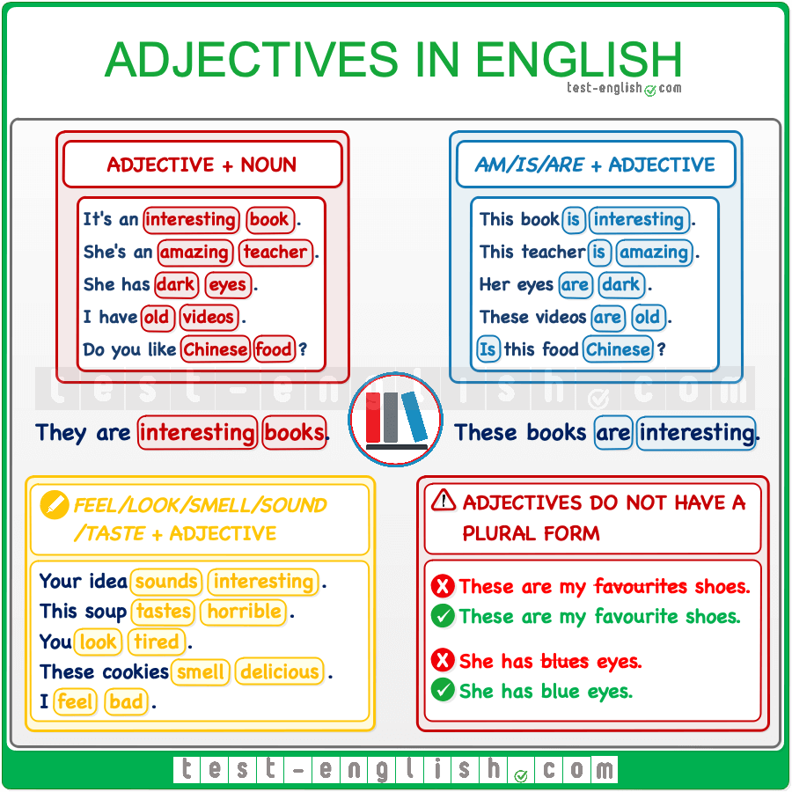

Download full-size image from Pinterest

Adjective + noun
When we use adjectives with a noun in English, the adjectives go before the noun.
- It’s an expensive guitar.
- It’s a guitar expensive.
- She has a new car.
- She has a car new.

Am/is/are + adjective
We can also use adjectives without a noun after the verb be.
- This guitar is expensive.
- Her car is new.
In questions, the adjective can go after be + subject.
- Is your car new?
- Are your classmates nice?

Feel/look/smell/sound/taste + adjective
We can also use adjectives without a noun after the verbs of the senses: feel, look, smell, sound, taste.
- Your idea sounds interesting.
- I don’t like this soup. It tastes horrible.
- You look tired.
- These cookies smell delicious.
- I feel depressed.

No plural
Adjectives in English have no plural. They are always singular.
- These are my favourite shoes.
- These are my favourites shoes.
- She has blue eyes.
- She has blues eyes.

Very/quite
We can use very and quite before the adjectives.
- It’s very expensive.
- It’s quite expensive.

Adverbs of manner

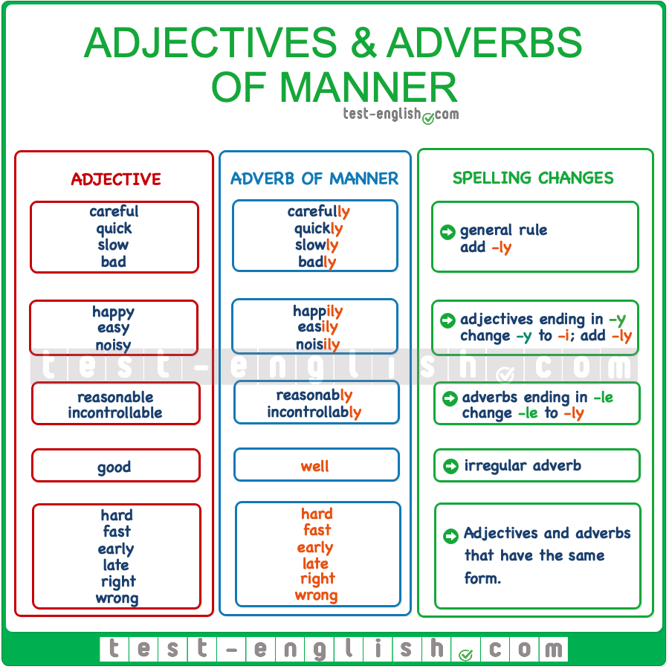

Download full-size image from Pinterest

Adverbs of manner: Use
We use adverbs of manner after a verb to describe the verb. We use an adverb of manner to say how something happens or how we do something.
- It rained heavily. (=We are describing how it rained.)
- He always replies quickly. (=We are describing how he replies)

Adverbs of manner: Position
We use adverbs of manner after the verb or, if there is an object, after verb + object.
- He drives carefully.
- She plays the guitar well.

Very, really, quite
We can use very, really, quite before an adverb of manner.
- It rained quite heavily.
- He drives quite carefully.
- She plays the guitar really well.

Adjectives
We use adjectives before a noun or after the verb be. You can review the topic of adjectives here.
- This is an expensive guitar.
- This guitar is expensive.

Adverbs of manner vs adjectives

Difference
We use adjectives to describe a noun (before a noun or after the verb be), and we use adverbs of manner to describe a verb (after the verb or verb + object). Compare:
- Robert plays the guitar well. (=We are describing the verb, i.e. how Robert plays the guitar.)
- Robert is a good guitar player. (=We are describing the noun, Robert.)
- Sara eats slowly.
- Sara is a slow eater.

Adjectives ending in -ly
Some words end in -ly, but they are adjectives, NOT adverbs: friendly, lovely, silly. We CANNOT transform these adjectives into adverbs of manner.

Comparative adjectives

We use more + adjective + than or adjective + -er + than to compare things or people.
- My car is more expensive than your car.
- I am older than my brother.
In this chart, you can see when we need to use more … than or -er than and the changes in spelling.
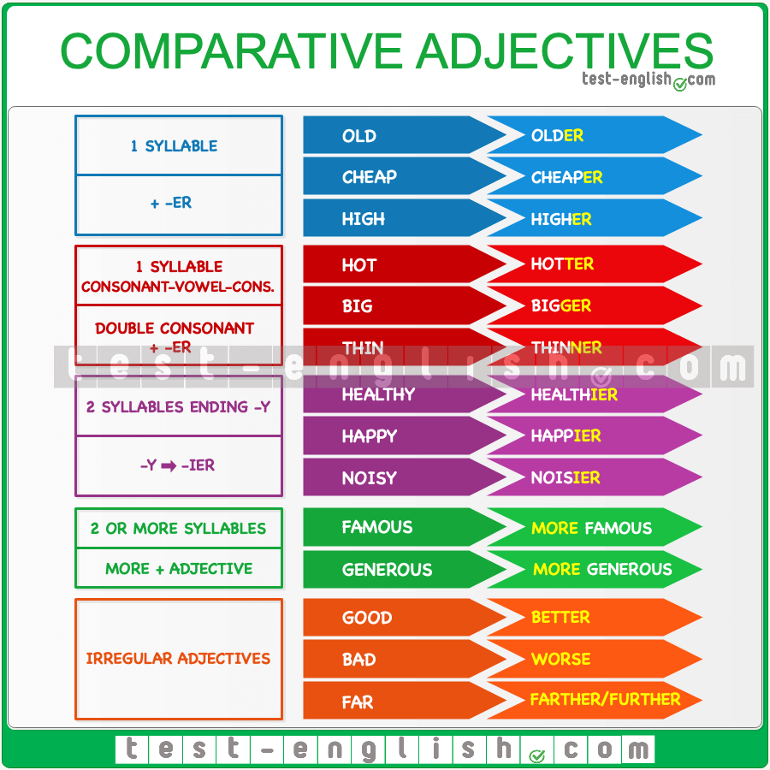

Download full-size image from Pinterest

Two things
We use the comparative form of an adjective to compare two things.
- Luke is taller than Mathew.
- This armchair is more comfortable than the sofa.

Less … than
When we compare two things, we can also use the form less + adjective + than (less ≠ more).
- Peter is less popular than Marta. (= Marta is more popular than Peter.)

Than me
If we use a personal pronoun after than, we need an object pronoun (me, you, him, etc.).
- My sister is taller than me.
- His sister is more intelligent than him.

Much/a bit + more
Before the comparative (more or –er), we can use much (=big difference) or a bit (=small difference).
- He’s a bit taller than me.
- Switzerland is much more expensive than Italy.

Common mistakes!

More or -er
We use more or –er, but we cannot use more + -er.
- My brother is more taller than me.
- My brother is taller than me.

More than (NOT that)
After a comparative adjective, we use than and NOT that.
- My brother is taller that me.
- My brother is taller than me.

Than + second element of the comparison
We use than + the second thing that we are comparing. When we don’t mention the second element of the comparison, we do NOT use than.
- I am tall, but my brother is taller than.
- I am tall, but my brother is taller.

Superlative adjectives

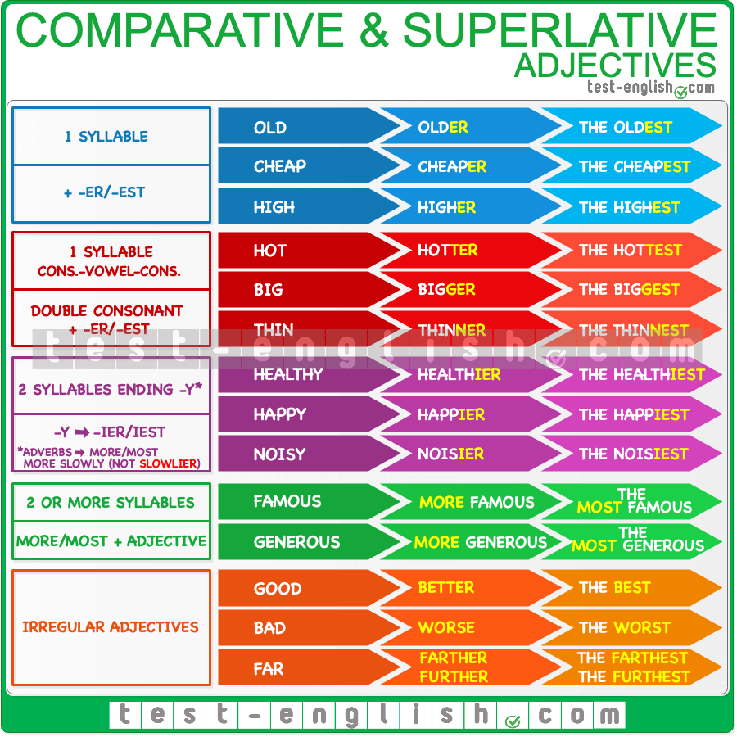

Download full-size image from Pinterest

Three or more things
We use the superlative form of an adjective or adverb to compare three or more things.
- Both John and his brother play football, but John is better.
- John and his two brothers all play football, but John is the best.

The best in
After the superlative we use in before names of places or before singular words referring to groups of people (class, school, team, family, etc.)
- The Everest is the highest mountain of the world.
- The Everest is the highest mountain in the world.
- She is the best student in the class.
- He’s the tallest in the family.

The / my / John’s
Before the superlative we always use the or a possessive adjective (my, your, his, etc.) or noun + possessive ‘s (Paul’s, Elisabeth’s, etc.)
- He is the best.
- This is my most expensive jacket.
- This is Paul’s best friend.

Conjunctions

And, but, or, so, because: Grammar chart

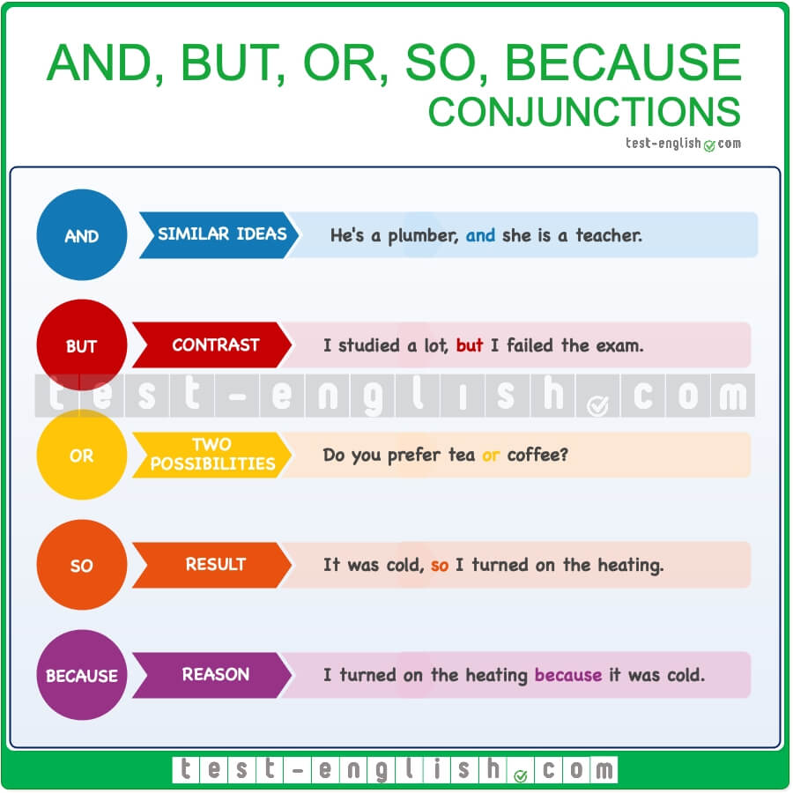

Download full-size image from Pinterest

And
We use and for adding similar information or ideas; it means ‘too’ or ‘in addition’.
- My brother is a plumber, and my sister is a teacher.
- They have an apartment in the city and a little house in the countryside.
When we are connecting sentences, we don’t need to repeat the subject (Tom, I, we, she, etc.)
- She got up and left. (=She got up and she left.)
- He was looking at us and smiling. (=He was looking at us and he was smiling.)

But
We use but for adding contrasting information, i.e. information that is different.
- I studied a lot, but I failed the exam.
- He is good but not the best.

Or
We use or to connect different possibilities.
- Would you like to go to the swimming pool or to the beach?
- He can go to a hotel or stay with us.
We use or (NOT and) in negative sentences to mean ‘not one thing and not another thing’.
- I don’t like oranges and lemons.
- I don’t like oranges or lemons.

Use and, but, or to connect similar words or phrases.
The items that we connect with and, but, or should be the same grammar type. Check these common mistakes:
- I like dancing and sing.
- I like dancing and singing. (-ing verb and -ing verb)
- Would you like to go to the beach or having an ice cream in the park?
- Would you like to go to the beach or to have an ice cream in the park? (to-infinitive and to-infinitive)

So
We use so to introduce the consequence or the result of something. The second part of the sentence is the result of the first part of the sentence.
- It was cold, so I turned on the heating.
- I spent three hours at the gym, so I’m really tired now.

Because
We use because to introduce the reason for something.
- I turned on the heating because it was cold.
- I’m speaking quietly because I don’t want to wake up the baby.

Prepositions

At, in, on: Prepositions of time

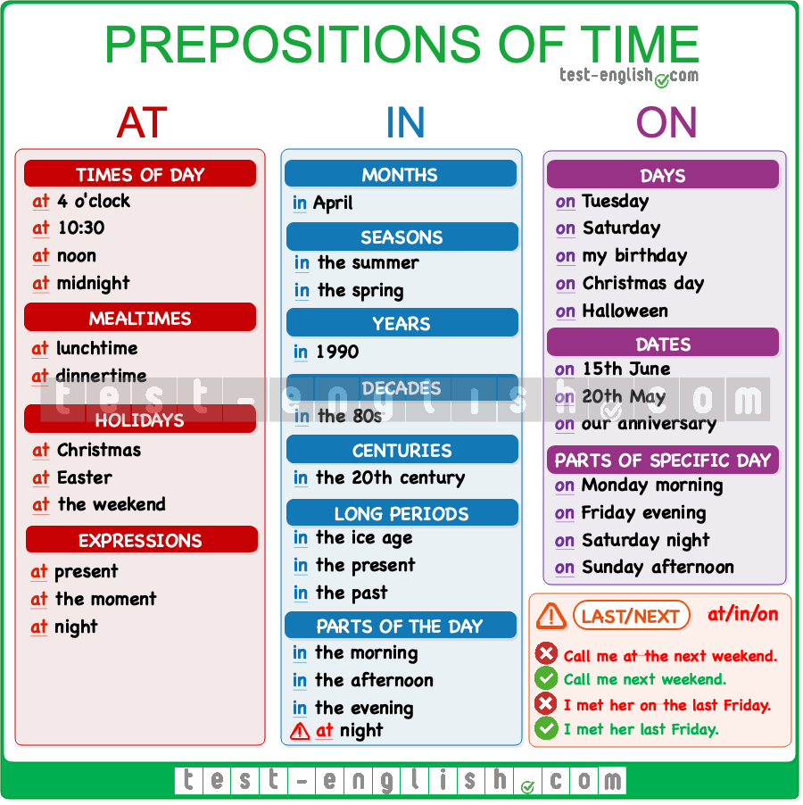

Download full-size image from Pinterest

At
Use at with times of day, including mealtimes, bedtime, etc.
- at 3 o’clock, at 10.30 am, at noon, at dinnertime, at bedtime, at sunrise, at sunset, at the moment
Use at in the following common expressions:
- at the weekend: I don’t usually work at the weekend.
- at Christmas/Easter: I stay with my family at Christmas.
- at the same time: We finished the test at the same time.
- at present/at the moment: He’s not home at present. Try later.

In
Use in with months, seasons, years, decades, centuries and long periods of time in general.
- in May, in the summer, in 1990, in the 1990s, in the 20th century, in the Ice Age, in the past/future

On
Use on followed by days and dates.
- on Sunday, on Tuesday mornings, on 6 March, on 25 December 2010, on Christmas Day, on Independence Day, on my birthday, on New Year’s Eve

Parts of the day:
- in the morning
- in the afternoon
- in the evening
- at night

Last, next, every and this
When we say last, next, every, this, we do not use at, in, on.
- I went to London last June.
- I went to London in last June.
- He’s coming back next Tuesday.
- He’s coming back on next Tuesday.
- I go home every Easter.
- I go home at every Easter.
- We’ll call you this evening.
- We’ll call you in this evening.

At, in, on: Prepositions of place

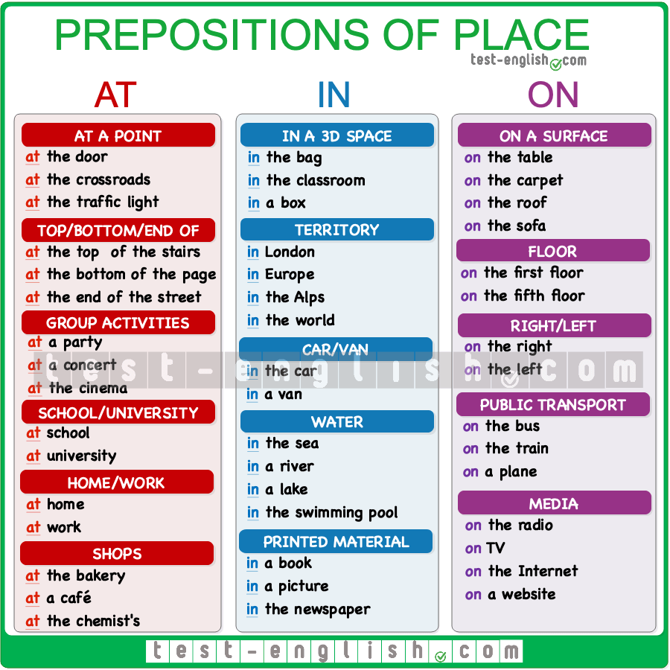

Download full-size image from Pinterest

At

At a point
We use at to refer to a point near something.
- Can you see that car at the traffic light? (=The car is at a point near the traffic light)
- Who is that man at the door? (=The man is at a point near the door)

At the top of/at the bottom of/at the end of
We use at in the expressions at the top of, at the bottom of and at the end of.
- She is at the top of the stairs.
- Please sign at the bottom of the page.
- The new café is at the end of the street.

Group activities
We use at to refer to group activities like parties, concerts, and other events.
- We were at the cinema.
- I didn’t see you at Jackie’s party.
- We met at a concert.

At + school/university/college
We normally use at with school, university and college.
- He is at school every morning until 12.
- I’m studying at Oxford University.

Be at home/work
We say be at home/at work (without the)
- She’s at home.
- She’s at the home.
- I’ll be at work all morning.
- I’ll be at the work all morning.

At the shop
We use at to refer to shops, restaurants, cafés, etc.
- I’m at the bakery.
- If you are at the chemist’s, can you buy some aspirin?

In

In a 3D space
We use in to refer to a position inside of a three-dimensional space.
- The book is in the bag.
- She is waiting in the classroom.

In a space with limits
We also use in for areas that have limits or boundaries, like continents, countries, cities, regions, etc.
- We are in France.
- I love the houses in the Alps.

In a car
We use in for cars and vans.
- They are in the car.

In the water
We also use in when something is in the water: in the sea, in the river, in the swimming pool, etc.
- The kids have fun in the swimming pool.

In a picture, in a book
We also use in for things that are printed in books, pictures, documents, etc.
- Who’s that woman in the picture?
- Does it say anything about the concert in the newspaper?

On

On a surface
We use on to refer to a position on a surface.
- The book is on the table.

On the first/second/etc. floor
We use on to refer to floors in a building.
- The office is on the third floor.

On the right/left
We use on in the expressions on the right and on the left.
- The office is on the third floor on the left.

On the bus/train/plane
We use on when we are using public transport: on the bus, on a train, on a plane, etc.
- She’s on the bus right now.

On TV/the radio/the Internet/a website
We use on when we read, see or learn something in the media.
- I saw it on TV last night.
- I learned it on the internet.

Next to, under, between, in front of, behind, over, etc.

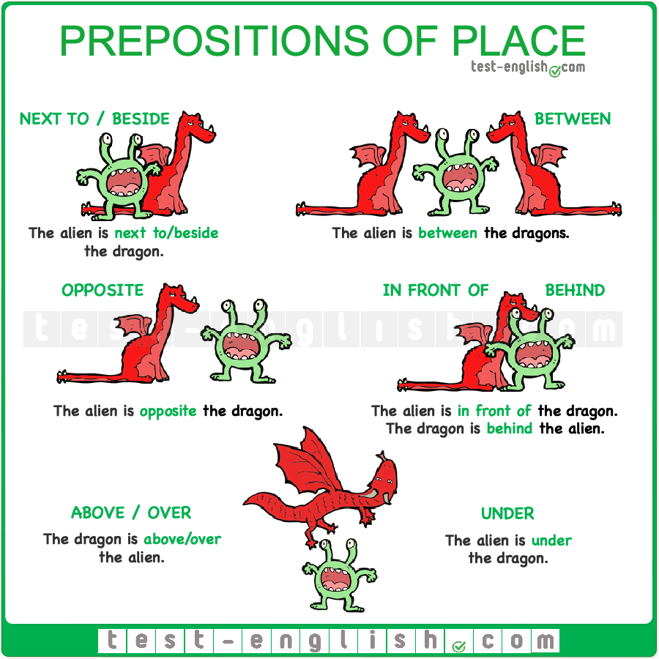

Download full-size image from Pinterest

Next to / beside
- We had a picnic next to/beside the river.
- Come and sit next to/beside me.

Between
- I live in a small town between Liverpool and Manchester.
- She is sleeping between her mum and dad.

In front of
- John sits in front of me in class.
- You are always in front of the mirror.

Behind
- She is hiding behind the curtains.
- We hang our coats behind the door.

Opposite
- I live opposite the supermarket (=on the other side of the road)
- I am sitting opposite him (=facing him)

Under
- The cat is hiding under the bed.
- Why are your shoes under the table?
- I’m wearing a white shirt under the jersey.

Above / over
Above and over mean ‘at or to a higher position’. Over is more common.
- She lives in an apartment above/over the grocery store.
- There is a shelf above/over the sink.

Questions

Word order in present simple questions

The order of words in an English question in present simple is QWASI: (Question Word) + Auxiliary + Subject + Infinitive.
- What do you do?
- Where do they live?
In Yes-No questions (questions that we answer saying yes or no) there is NO Question Word.
- Do you speak English?
- Does she live here?
The auxiliary verb in present simple is be or do/does. Below, you can see a grammar chart on the order of words in present simple questions with be or do/does.
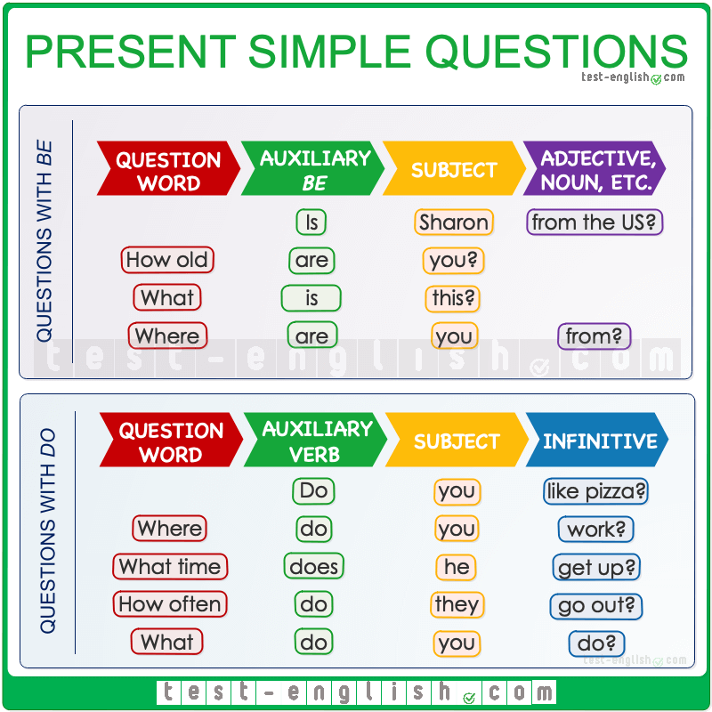

Download full-size image from Pinterest

Questions with am/is/are
When the verb in the sentence is be, we use am/is/are as the auxiliary verb before the subject. Then the word order is QWAS: (Question Word) + Auxiliary (am/is/are) + Subject

Questions with do/does
When we have a verb that is not be, we use do/does as the auxiliary verb.
We use does with he/she/it and do with I/you/we/they. Remember that the main verb after the subject is in the infinitive form (NOT -s or -es).
- What does she do?
- What does she does?
- Where does he work?
- Where does he works?

Question words – Grammar chart
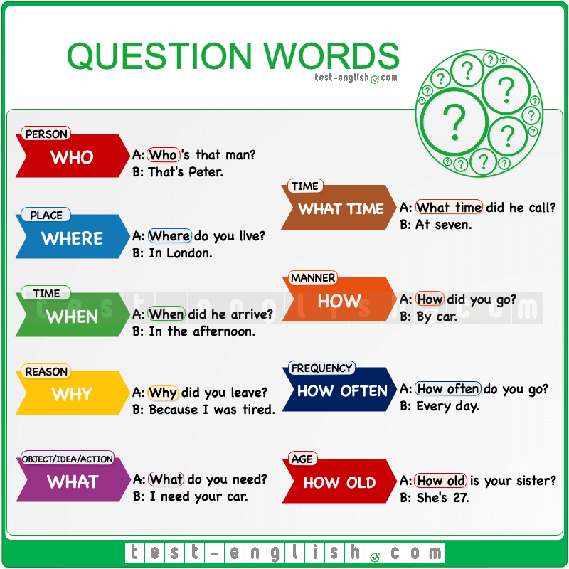

Download full-size image from Pinterest

What + noun
We often use the question word what + noun as a question word: what time, what colour, what size, etc.
- What colour is your jacket?
- What size do you want?
- What car does he have?

How + adjective/adverb
We can also use how + adjective/adverb as a question word in phrases like how often, how old, how tall, etc.
- How fast is your car?
- How big is her house?
- How often do you play sports?

Word order

Adverbs of frequency

We use adverbs of frequency with the present simple to talk about how often something happens.
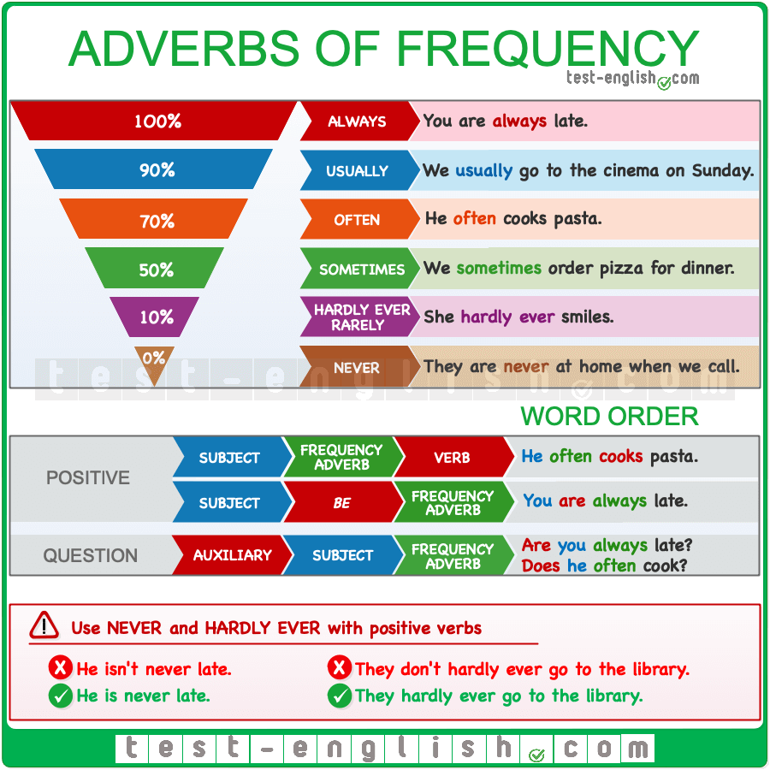

Download full-size image from Pinterest

Position
Adverbs of frequency go before the verb but after the verb be.
In negative sentences, the adverb of frequency goes after don’t/doesn’t:
- We don’t often go to bed late.
- He doesn’t always agree with me.
In questions, adverbs of frequency go after the subject.
- Is he always late?
- Do they often go to the library?

Never/hardly ever
The adverbs never and hardly ever (=almost never) have a negative meaning, but they are used with a positive verb:
- He is never late.
- He isn’t never late.
- They hardly ever go to the library.
- They don’t hardly ever go to the library.

Expressions of frequency
There are other expressions that we use to talk about frequency: once a day, twice a week, three times a month, every day, etc. These expressions are longer (2 words or more), and they go at the end of the sentence.
- I brush my teeth three times a day.
- I see her every day.

Basic word order in English: Grammar chart

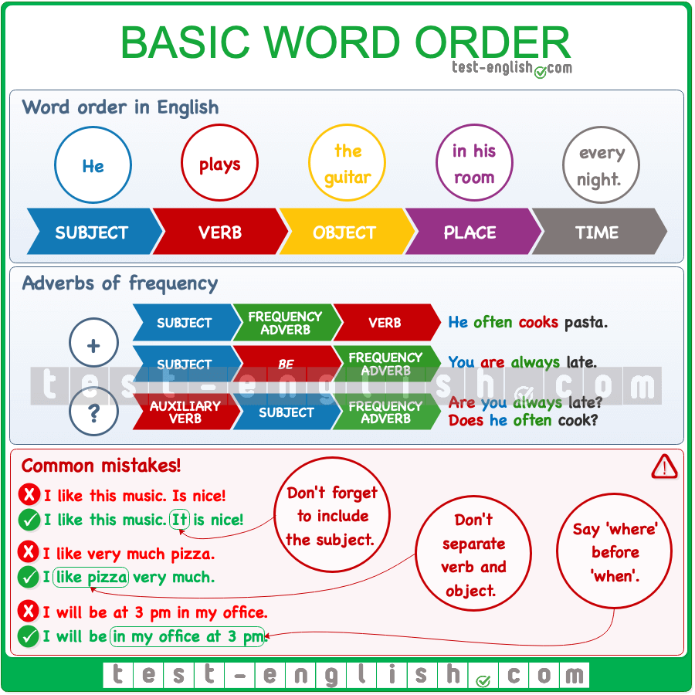

Download full-size image from Pinterest

Subject + verb
In English, we normally need to include the subject in a sentence. The subject goes before the verb.
- We dance.
- She is waiting.
We use it or they as a subject to talk about something that we mentioned before.
- I like your guitar. Is nice.
- I like your guitar. It is nice.
- Can you see those trees? Are beautiful.
- Can you see those trees? They are beautiful.
We don’t include the subject in imperative sentences.
- Sit down, please.
- Call me soon.
We can put an adverb of frequency between the subject and the verb. BUT adverbs of frequency go after the verb when the verb is be.
- We often dance.
- BUT: You are always late.

Verb + object
When there is an object in the sentence, we need to put it after the verb. Verb and object are together.
- I like very much pizza.
- I like pizza very much.
- She plays every day the guitar.
- She plays the guitar every day.

Place + time
We normally say ‘where’ and ‘when’ something happens in this order.
- She arrives in the morning at the hospital.
- She arrives at the hospital in the morning.
- Will you be at 3 pm in the office?
- Will you be in the office at 3 pm?

